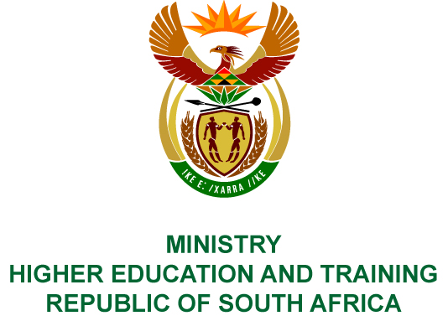
Private Bag X893, Pretoria, 0001, Tel: 012 312 5555, Fax: 012 323 5618
Private Bag X9192, Cape Town, 8000, Tel: 021 469 5150, Fax: 021 465 7956
Memorandum from the Parliamentary Office
NATIONAL ASSEMBLY
FOR WRITTEN REPLY
QUESTION 76
DATE OF PUBLICATION OF INTERNAL QUESTION PAPER: 07/12/2019
INTERNAL QUESTION PAPER NO 01 OF 2019
Mr A P van der Westhuizen (DA) to ask the Minister of Higher Education and Training:
What is the current backlog of (a) administration, (b) reconciliations and (c) payments related to the 2018 academic year that the National Student Financial Aid Scheme has to deal with before commencing with the 2019 academic year?
NW81E

REPLY:
The National Student Financial Aid Scheme (NSFAS) has provided the following information in response to the question.
The global picture for unresolved applications from 2017 and 2018 as at 14 February 2019 is
83 186. Of these, 19 113 relate to unsigned loan/bursary agreements. Without signed contracts, the NSFAS Act prevents payments to be made to the applicant or to the educational institution at which they are registered. The details of the students with unsigned contracts are sent regularly to their host institution for them to ensure that the contracts are signed. Once signed, fees and allowances can be paid immediately.
There are a further 64 073 outstanding cases where there are internal system issues that prevent final resolution. Of these, 54 807 (10 333 from 2017 and 44 474 from 2018) relate to changes in fees or allowances that, for a number of reasons, are rejected by the processing algorithm. The causes of these rejections have now been identified, and the algorithm is currently being updated to resolve the blockage. NSFAS has an internal target to complete this work by 22 February 2019. It is important to note that all these cases refer to students who have received allowances and fee payments based on the original figures submitted by the registering institution. The problems relate to subsequent changes due to a course or personal circumstance changes.
The remaining 9 266 cases relate to internal procedure issues that prevented individual student accounts to be generated. These issues have been identified and are being fixed. These will all be resolved by 22 February 2019.

