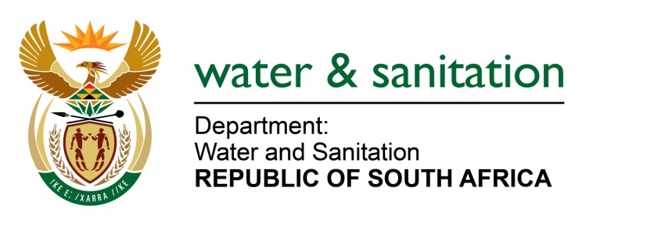

MINISTER OF WATER AND SANITATION

FOR WRITTEN REPLY

QUESTION NO 757

DATE OF PUBLICATION IN INTERNAL QUESTION PAPER: 11 MARCH 2022
(INTERNAL QUESTION PAPER NO. 9)

757. Mr K Ceza (EFF) to ask the Minister of Water and Sanitation:
What interventions has his department made to support (a) provinces and (b) municipalities, such as the Nelson Mandela Bay Metropolitan Municipality, that are suffering from chronic water shortages?
NW933E
---00O00---

MINISTER OF WATER AND SANITATION

- The Department of Water and Sanitation (DWS) has over the years developed interventions to address water shortages within the country. This intervention includes forms of grants(conditional) that are aimed at provision of sustainable water supply through the provinces.

The DWS is managing two infrastructure grant funding programs namely Regional Bulk Infrastructure Grant (RBIG) and Water Services Infrastructure Grant (WSIG). The two grants subsidise Water Services Authorities to implement bulk projects through RBIG and reticulation projects through WSIG. The two programs fund projects that reduce water services infrastructure backlogs and enhance access by ensuring sustainability of services. The projects include-:

- New infrastructure development
- Upgrade of existing infrastructure
- Refurbishment and or rehabilitation of existing infrastructure etc

- For the 2021/22 financial year, the department is implementing 126 projects in all the 9 provinces which are funded through RBIG and 230 through WSIG to address water shortages and provide sustainable and adequate water provision in different municipalities. Part of the intervention will include the implementation of the District Development Model.

---00O00---

