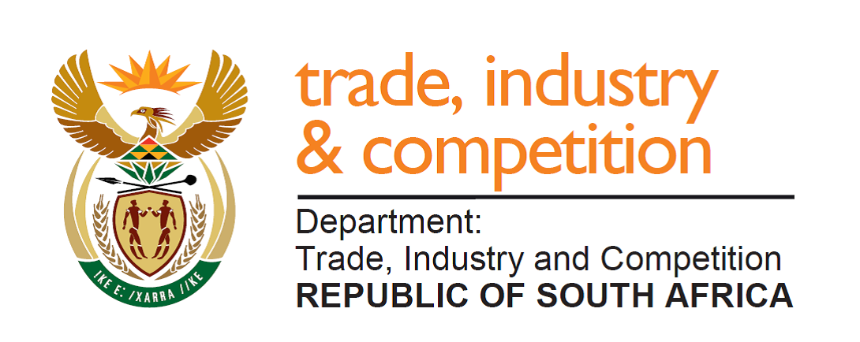

NATIONAL ASSEMBLY

WRITTEN REPLY

PARLIAMENTARY QUESTION 757

DATE OF PUBLICATION: 30 AUGUST 2019

Ms T A Khanyile (DA) to ask the Minister of Trade and Industry:
(1) Whether his department hosted any event and/or function related to its 2019 Budget Vote debate; if so, (a) where was each event held, (b) what was the total cost of each event and (c) what is the name of each person who was invited to attend each event as a guest;
(2) whether any gifts were distributed to guests attending any of the events; if so, (a) what are the relevant details of the gifts distributed and (b) who sponsored the gifts? NW1802E
Reply

The departments of Economic Development and Trade and Industry did not host any event or function for the 2019 Budget Vote. No gifts were distributed.

-END-

