NATIONAL ASSEMBLY
36/1/4/1(201900079)

FOR WRITTEN REPLY

QUESTION 757

DATE OF PUBLICATION IN INTERNAL QUESTION PAPER: 15 MARCH 2019 fINTERNAL QUESTION PAPER NO 8-2019)

757. Mr M Tshwaku (EFF) to ask the Minister of Police:

What is the total number of children who were killed at school in 2018?

REPLY:

NW880E

Province | Number of children who were killed at schools in 2018
Eastern Cape  Free Sate | 0
Gauteng | 0
KwaZulu-Natal
Limpopo | 3
Mpumalanga
North West | 4
Northern Cape | 1
Western Cape | 2
Total

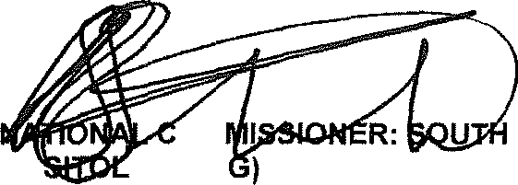
GENERAL AFRICAN POLICE SERVICE
KJ
OM E (SOE

Date: §§{g -0 - g

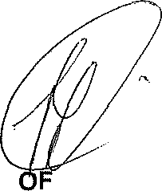
Reply to question 757 recommended/cat o ended

MINISTER POLICE BH CELE, M

