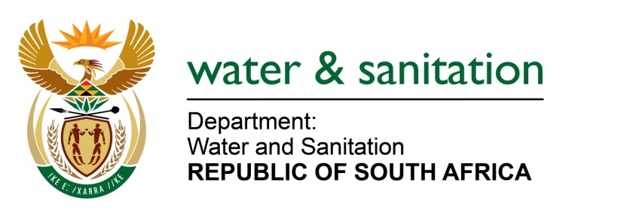

MINISTER OF WATER AND SANITATION

FOR WRITTEN REPLY

QUESTION NO 756

DATE OF PUBLICATION IN INTERNAL QUESTION PAPER: 11 MARCH 2022
(INTERNAL QUESTION PAPER NO. 9)

756. Ms R N Komane (EFF) to ask the Minister of Water and Sanitation:
Which measures has his department put in place to ensure that the residents of Makolokwe in Rustenburg Local Municipality have clean, drinkable water, as they have been without such water since last year?
NW932E
---00O00---

MINISTER OF WATER AND SANITATION
The Department of Water and Sanitation has allocated R15 million, through Water Services Infrastructure Grant (WSIG), for the Makolokwe Water Supply Project. This project is intended to connect to the water supply pipeline from Glencor Mines, which is still under negotiation.
The design of the pipeline and connection is completed, and tender document is ready for the construction. The anticipate commencement of construction is May 2022, the projected completion date is August 2022.

---00O00---

