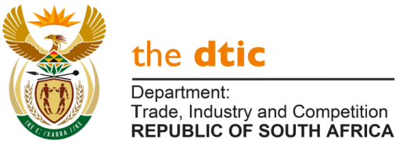

THE NATIONAL ASSEMBLY

QUESTION FOR WRITTEN REPLY

QUESTION 753

DATE OF PUBLICATION: 11 MARCH 2022

Mrs Y N Yako (EFF) to ask the Minister of Trade, Industry and Competition:

Noting the high unemployment rate in the Nelson Mandela Bay Metropolitan Municipality, what (a)(i) total number of companies have been assisted by his department in the specified area and (ii) is the racial breakdown of the ownership of the specified companies and (b) are the success stories in the master plans already set up by his department? NW929E

REPLY

Within the available time, the Department advises that 132 projects (involving 112 firms) have been supported in the Nelson Mandela Bay Metropolitan Municipality through 3 programmes, namely the support administered by the Industrial Financing Branch, the funding by the Industrial Development Corporation and the transactions of the National Empowerment Fund. Other programmes are in the process of recording their activities at District Municipality level, and the figures may be updated in future.

Data on ownership demographics for firms in Nelson Mandela Bay metro are available as follows:
- The IDC supported 64 firms since the 2018/19 financial year. Forty-one (41) firms have black shareholding, ranging from four percent to 100% black ownership. Nineteen (19) of the firms were 100% black-owned.
- The NEF supported 12 businesses all of which are black-owned and managed. More broadly in the E Cape, the NEF approved R706 million to date.
- The Industrial Financing Branch supported 61 projects, involving 36 companies, 1 Trust and 11 projects in Coega, for 2018/19 to January 2022. Demographic details will be compiled by the Department. The Department advises that R1,7 billion was approved for the 61 projects, with total investment generated of R3,5 billion, which are projected to create 1 150 new jobs and retain 13 850 direct jobs with a further 926 construction jobs.

The Department has highlighted a number of success stories involving masterplan sectors in the presentation to Parliament on 27 October 2020. These include sectors with exposure in the Eastern Cape, including the following:
- The auto sector, covering both production of cars, bakkies and trucks as well as the manufacture of components locally. This is important for Nelson Mandela Bay as the auto sector is the largest manufacturing sector in the E Cape. Further examples of progress relates to VW production, Isuzu’s new model that is being rolled out and the new auto plant, namely BAIC.
- Clothing, textiles and footwear, with a stronger focus on localisation of supply-chains.
- Steel and metal fabrication, with programmes to rebuild the foundations of the sector.

-END-

