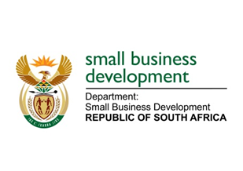
NATIONAL ASSEMBLY

QUESTION FOR WRITTEN REPLY

“752. Mr M H Hoosen (DA) to ask the Minister of Small Business Development:

(1) Whether her department hosted any event and/or function related to its 2019 Budget Vote debate; if so, (a) where was each event held, (b) what was the total cost of each event and (c) what is the name of each person who was invited to attend each event as a guest;
(2) whether any gifts were distributed to guests attending any of the events; if so, (a) what are the relevant details of the gifts distributed and (b) who sponsored the gifts?”
NW1797E
REPLY:

- Following the proceedings of the Budget vote held on 12 July 2019, the Minister hosted a brief Stakeholder engagement session.

(a) The Stakeholder engagement meeting was held in the Parliamentary precinct at Palm Court, Marks Building.
(b) The total cost spent was R17, 866.00.
(c) The Protection of Personal Information Act prohibits the sharing personal details of participants however, the invitees comprised of stakeholders from SMME Organisations and Cooperatives, Incubators, Corporate entities, members of the public and support staff.

(2) No gifts were distributed.
(a)&(b) Not applicable.

