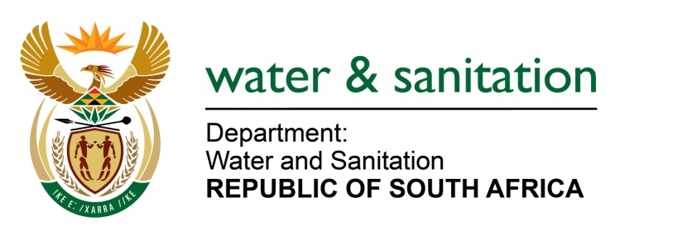

NATIONAL ASSEMBLY

FOR WRITTEN REPLY

QUESTION NO 752

DATE OF PUBLICATION IN INTERNAL QUESTION PAPER: 18 MARCH 2016
(INTERNAL QUESTION PAPER NO. 9)

752. Mr A R McLoughlin (DA) to ask the Minister of Water and Sanitation:

(1) With reference to her department’s Third Quarter Expenditure Report for the 2015-16 financial year, what capital assets were purchased from the R5,9 billion that was spent from her department’s operational budget between 1 April 2015 and 31 December 2015, in each case detailing (a) how much each item cost, (b) the (i) nature and (ii) location of each item and (c) the purpose of the specified acquisitions;

(2) with reference to her department’s underspending of R3,275 billion with regard to Transfers and Subsidies and Operational Expenditure by the end of the third quarter of the 2015-16 financial year, what are the full details of the plans that have been put in place to ensure that her department achieves its targets by the end of the 2015-16 financial year without resorting to fiscal dumping;

(3) (a) how many employees are (i) employed by her department and (ii) compensated through transfers from her department and (b) how much is spent on the compensation of employees at each different (i) salary scale and (ii) level of employment;

(4) how does she reconcile the apparent contradiction between the statement in the report that read respectively that the slow spending is expected to be resolved as the implementation of projects gets accelerated towards the end of the financial year and that it is projected that the department will underspend towards the end of the financial year on the second to last page of the report;
(5) (a) how did her department fund the 419.7% overspend on the Water Trading Entity: Operations and Maintenance budget line and (b) what was the reason for such a high overspend? NW870E
---00O00---
REPLY:

(1) As at 31 December 2015, an amount of R47.864 million was spent on the adjusted allocation of R132.717 million for capital assets in the normal voted funds (operational budget) of the Department. The details of each item cost, and the location thereof are outlined in Annexure A.
- Machinery and Equipment: These assets which can be used continuously or repeatedly in production for at least one year. Examples of Machinery and Equipment are Water laboratory equipment, construction and maintenance equipment, auto visual equipment, photographic equipment, office furniture, computer hardware, printing equipment, etc

- Software and Intangible Assets are the identifiable non-monetary asset without any physical substance. Examples of intangible fixed assets are mineral exploration rights; computer software; literary and artistic originals; and miscellaneous other intangible fixed assets. To qualify as a fixed asset, the item must be intended for use in production for more than one year and its use must be restricted to the units that have established ownership rights over it or to units licensed by the owner. (The units that have established ownership rights refer to the entity that created the software for example “Microsoft” and units licensed by the owner refers to the unit buying a license to use or the right to use the software, but will not be able to change the software).

(2) Refer below for full details of the plans that have been put in place to ensure that her department achieves its targets by the end of the 2015-16 financial year without resorting to fiscal dumping:

- Reallocation of budget within projects for improved level of expenditure between the slow and fast moving projects;
- This will assist to expedite service delivery and improve expenditure. Over and above this, the following actions were to be taken;
- Dedicated efforts to collect outstanding invoices from all suppliers (Including municipalities) for work completed;
- Drive and expedite the recruitment and selection processes for the recently advertised positions;
- Improve working relations between line function, finance and municipalities to improve supply chain management processes;
- Perform an internal expenditure review and provide more realistic cash flow projections and practical measures (recovery plans) to put in place to ensure adherence to the cash flow projections (At project level, for all programmes).
(3) As at 31 December 2015, an amount of R1.021 billion was spent on the adjusted allocation of R1.428 billion for Compensation of Employees, refer to Annexure B.
(4) The Water Trading Entity spent the allocated funds in line with Treasury Regulations and Departmental Policy regarding the Budget.
(5) The Department’s operation and maintenance expenditure is reflected under operational clusters in the third quarter report. According to the report, there is no overspending reflected therein. The Audited financial statement for the 2014/15 financial year as reflected on the comprehensive income does not show any over expenditure on operation and maintenance.
---00O00---

Annexure A

The details of each item cost, and the location thereof are outlined in the table below:

OFFICE | MACHINERY AND EQUIPMENT |  |  | SOFTWARE & INTANGIBLE ASSETS |  |  | Adjusted Budget | Spent  31 Dec 15 | %  Spent
 | Adjusted Budget | Spent  31 Dec 15 | %  Spent | Adjusted Budget | Spent  31 Dec 15 | %  Spent
EASTERN CAPE | 8,019 | 2,082 | 26% | - | - | 0% | 8,019 | 2,082 | 26%
FREE STATE | 5,684 | 1,089 | 19% |  | - | 0% | 5,684 | 1,089 | 19%
GAUTENG | 2,742 | 1,372 | 50% |  | - | 0% | 2,742 | 1,372 | 50%
KWAZULU-NATAL | 1,865 | 985 | 53% |  | - | 0% | 1,905 | 985 | 52%
LIMPOPO | 18,216 | 3,644 | 20% |  | - | 0% | 18,216 | 3,644 | 20%
MPUMALANGA | 3,874 | 1,164 | 30% |  | - | 0% | 3,874 | 1,164 | 30%
HEAD OFFICE | 40,838 | 24,354 | 60% | 40, 370 | 10,306 | 33% | 81,168 | 34,661 | 43%
NORTH WEST | 1,229 | 327 | 27% |  | - | 0% | 1,229 | 327 | 27%
NORTHERN CAPE | 2,758 | 829 | 30% |  | - | 0% | 2,758 | 829 | 30%
WESTERN CAPE | 7,122 | 1,706 | 24% |  | - | 0% | 7,122 | 1,706 | 24%
GRAND TOTAL | 92,347 | 7,557 | 41% | 40,370 | 10,306 | 33% | 132,717 | 47,864 | 36%

Annexure B
The details for Compensation of Employees are outlined in the table below:

Classification Item | Programme | Adjusted Budget | Spent  31 Dec 15 | %  Spent
COMPENSATION OF EMPLOYEES | ADMINISTRATION | 645,589 | 481,719 | 75%
 | WATER PLANNING & INFORMATION MAN | 350,644 | 244,837 | 70%
 | WATER INFRASTRUCTURE DEV | 114,679 | 60,237 | 53%
 | WATER & SANITATION SERVICES | 148,102 | 96,939 | 65%
 | WATER SECTOR REGULATION | 169,383 | 137,694 | 81%
Grand Total |  | 1,428,397 | 1,021,427 | 72%
The funds allocated to the department for each salary scale and) level of employment are as follows:
Salary Level | Number of officials | Original Budget per Salary Level
1 | 1 | 98
2 | 305 | 22,750
3 | 381 | 56,326
4 | 165 | 23,912
5 | 744 | 169,567
6 | 423 | 126,911
7 | 524 | 143,440
8 | 450 | 146,085
9 | 299 | 109,661
10 | 371 | 149,050
11 | 290 | 145,574
12 | 287 | 216,925
13 | 116 | 115,818
14 | 35 | 45,546
15 | 9 | 14,582
16 | 3 | 5,888
Total | 4,404 | 1,492,133

