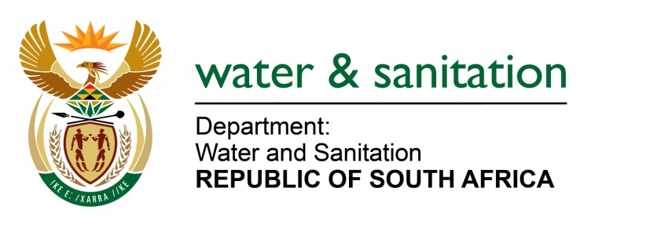

MINISTER OF WATER AND SANITATION

FOR WRITTEN REPLY

QUESTION NO 751

DATE OF PUBLICATION IN INTERNAL QUESTION PAPER: 11 MARCH 2022
(INTERNAL QUESTION PAPER NO. 9)

751. Mr T M Langa (EFF) to ask the Minister of Water and Sanitation:
By what date will clean running water be provided to the community of Thohoyandou in Limpopo, where ongoing sanitation issues are being experienced across the region?
---00O00---

MINISTER OF WATER AND SANITATION

The Vhembe District Municipality (DM) is both the Water Services Authority (WSA) and the Water Services Provider (WSP) that provides water to Thohoyandou.

The Vhembe DM provides water to Thohoyandou and surrounding areas through:
- The Vondo Water Treatment Works is located at Phiphidi supplies water to various communities including Golgota, Thoyandou Units D and G.
- The Nandoni-Thohoyandou pipeline (NR6) supplies water to the following areas: Thohoyandou P East and West, the Thohoyandou CBD, Thohoyandou Units F, J, K, L, M, N, and University of Venda.

It should be noted that the Vhembe DM is in the process of upgrading the Vondo WTW from 52ML/d to 75ML/d to meet the current and future demand for water in Thohoyandou. The project has been allocated R334 258 638.00 through the Municipal Infrastructure Grant. An allocation of R534 322 941.46 has also been set aside for maintenance of the plant. The project commenced on 10 May 2018 and is expected to be completed by 30 June 2022.

---00O00---

