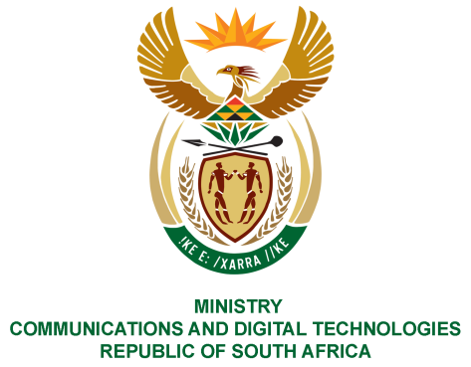
PARLIAMENT OF THE REPUBLIC OF SOUTH AFRICA
NATIONAL ASSEMBLY
WRITTEN REPLY

QUESTION NO: 750
DATE OF PUBLICATION: 10 March 2023
QUESTION PAPER NO: 08

Ms T Bodlani (DA) to ask the Minister of Communications and Digital Technologies:

Whether the Digital Economy Framework and/or strategy for the Republic has been developed; if not, (a) why not and (b) by what date will it be developed; if so, what are the relevant details?

REPLY:

Yes. The Department of Communications and Digital Technologies (DCDT) has developed the draft Digital Economy Framework and Strategy and it is currently undergoing final internal consideration and comments, before being submitted to the new Minister for his consideration and Cabinet for approval and publishing in the Government gazette for public comments and consultation with the broader South African society and industry.

The relevant details will only be shared after Cabinet approval.

Thank You.

