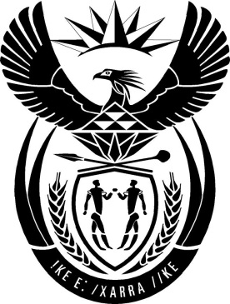

MINISTRY: PUBLIC SERVICE AND ADMINISTRATION

REPUBLIC OF SOUTH AFRICA

NATIONAL ASSEMBLY

QUESTION FOR WRITTEN REPLY

DATE: 30 AUGUST 2019

QUESTION NO: 750

Mr N E Hinana (DA) to ask the Minister of Public Service and Administration:
(1) Whether his department hosted any event and/or function related to its 2019 Budget Vote debate; if so, (a) where was each event held, (b) what was the total cost of each event and (c) what is the name of each person who was invited to attend each event as a guest;
(2) Whether any gifts were distributed to guests attending any of the events; if so, (a) what are the relevant details of the gifts distributed and (b) who sponsored the gifts? NW1795E
REPLY

- The Department of Public Service and Administration did not host any event and/or function related to its 2019 Budget Vote debate.

- N/A

