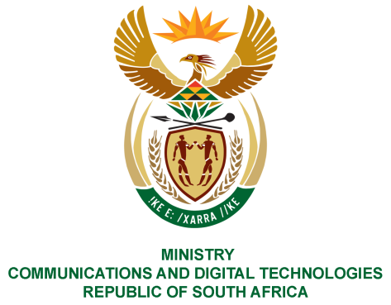
PARLIAMENT OF THE REPUBLIC OF SOUTH AFRICA
NATIONAL ASSEMBLY
WRITTEN REPLY

QUESTION NO: 749
DATE OF PUBLICATION: 10 March 2023
QUESTION PAPER NO: 08
Ms T Bodlani (DA) to ask the Minister of Communications and Digital Technologies:
- Whether his department is on track to complete the Cost of Communication review model and/ plan by 31 March 2023, if not which date will this be completed, if so, what are the relevant details?

NW848E
REPLY:

- No. The Department is finalising a research study that will serve as the basis for the Cost to Communication review model and/or plan for the 2022/2023 annual accounting period. The study will provide the required information for the construction of the review model and/or plan, which will be completed at the end of 2023/2024 financial year.

Thank You.

