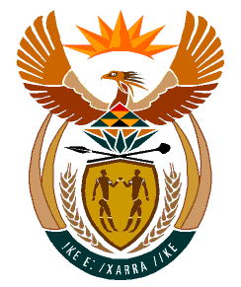

MINISTRY:
HUMAN SETTLEMENTS, WATER AND SANITATION
REPUBLIC OF SOUTH AFRICA

NATIONAL ASSEMBLY

QUESTION FOR WRITTEN REPLY

QUESTION NO.: 744

DATE OF PUBLICATION: 30 AUGUST 2019

Dr D T George (DA) to ask the Minister of Human Settlements, Water and Sanitation:
(1) Whether her department hosted any event and/or function related to its 2019 Budget Vote debate; if so, (a) where was each event held, (b) what was the total cost of each event and (c) what is the name of each person who was invited to attend each event as a guest;
(2) whether any gifts were distributed to guests attending any of the events; if so, (a) what are the relevant details of the gifts distributed and (b) who sponsored the gifts? NW1789E

REPLY:

(1) The Department of Water and Sanitation did not host any function related to its 2019 Budget Vote.

The Department of Human Settlements hosted a function on 9 July 2019 that launched the Guide on Neighbourhood Planning and Design, the Red Book. This was in line with the 2019-2020 delivery priorities as pronounced in the Budget Speech.

The launch referred to above:
- was held at the Cape Town International Convention Centre;
- cost the Department an amount of R 400 223.76; and
- was attended by Members of the Portfolio Committee on Human Settlements, Water and Sanitation, Members of the Executive Council (MECs), representatives from the entities reporting to me, the financial and construction sectors, social partners, the academia, officials from both my Departments, amongst others.

(2) No.

(a) Falls away

(b) Falls away

