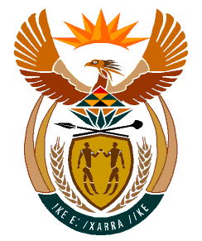

MINISTRY
HUMAN SETTLEMENTS
REPUBLIC OF SOUTH AFRICA

Private Bag X645, Pretoria, 0001. Tel: (012) 421 1309, Fax: (012) 341 8513

Private Bag X9029, Cape Town, 8000. Tel (021) 466 7603, Fax: (021) 466 3610

NATIONAL ASSEMBLY
QUESTION FOR WRITTEN REPLY
QUESTION NUMBER: PQ 740 [NW915E)
DATE OF PUBLICATION: 11 MARCH 2022

740. Ms B Mathulelwa (EFF) to ask the Minister of Human Settlements:

By what date will dignified toilets be built for the community of uMdoni Ward 13 in KwaZulu-Natal, who are currently living in inhumane conditions, because their mobile toilets have not been attended to for a period of over six months? NW915E
REPLY:

The provision of toilets and other related sanitation facilities does not fall within the mandate of the Department of Human Settlements. The Question may therefore be well answered by the Department of Water and Sanitation as it falls within its mandate.

