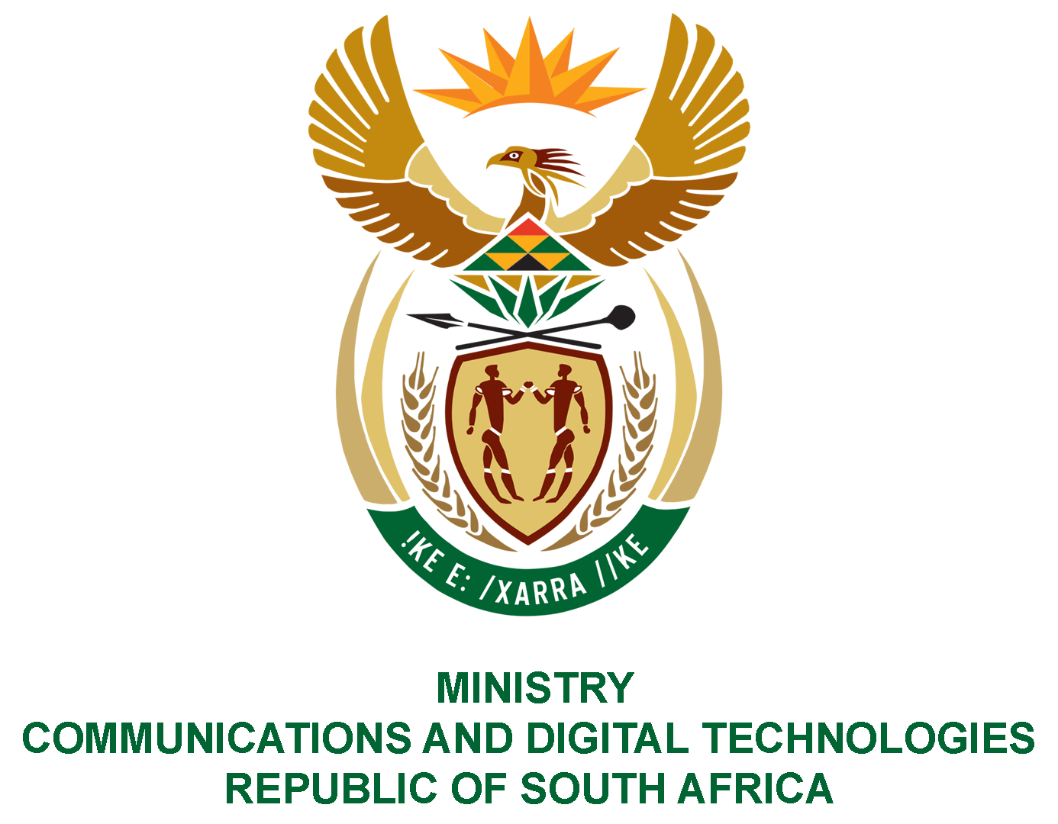

PARLIAMENT OF THE REPUBLIC OF SOUTH AFRICA
NATIONAL ASSEMBLY
WRITTEN REPLY

QUESTION NO: 740
DATE OF PUBLICATION: 01 May 2020
QUESTION PAPER NO: 13

Ms P T van Damme (DA) to ask the Minister of Communications:

Whether (a) her department and/or (b) any entities reporting to her, sponsored political party (i) advertisements, (ii) events and/or (iii) paraphernalia in the 2018-19 financial year; if so, (aa) which political party was sponsored and (bb) what was the monetary value of the sponsorship in each case?
NW944E

REPLY:

I was advised by the Department and entities as follows:

(a)& (b) The Department and entities did not sponsor any political parties in the 2018/19 financial year.
- None
- None
- None

(aa) N/A
(bb) N/A

MR J MTHEMBU, MP
ACTING MINISTER OF COMMUNICATIONS AND DIGITAL TECHNOLOGIES

