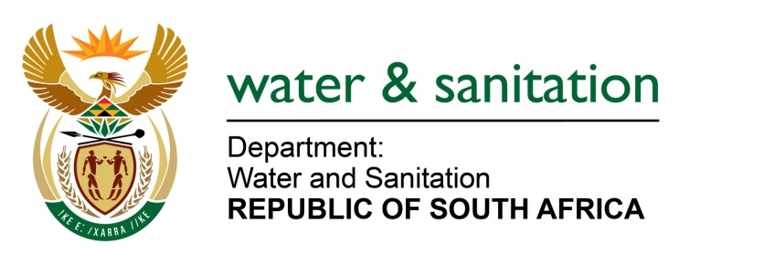

NATIONAL ASSEMBLY

FOR WRITTEN REPLY

QUESTION NO 74

DATE OF PUBLICATION IN INTERNAL QUESTION PAPER: 10 FEBRUARY 2022
(INTERNAL QUESTION PAPER NO. 1)

74. Mr A C Roos (DA) to ask the Minister of Water and Sanitation:

(1) With regard to the bulk water supply by Magalies Water to Region 5 of the City of Tshwane, Gauteng, what is the status of the repair and/or replacement project of the 210m water supply pipeline at Wilge Dam that was washed away in December 2019, which affects water supply to the Refilwe, Cullinan, Rayton, Petra Diamond Mine and Zonderwater areas.

(2) In light of the fact that the inability of Magalies Water to resolve the issue is causing water shortages for residents and reservoir levels to run low, what is the deadline for the full restoration of the bulk water supply.

(3) What measures are being put in place to (a) deal with power supply issues and/or (b) erect temporary power supply solutions as Magalies Water cites Eskom power outages as the reason for regular bulk water shortages to the area?

NW78E
---00O00---

MINISTER OF WATER AND SANITATION

A temporary raw water pipeline and pump station was installed by the Petra Diamond Mine in December 2019 after the flood damage of the Wilge Dam infrastructure. The temporary pumping system can supply on average, 11 Ml/d to the users. The average demand in Cullinan for the past financial two years was about 10 – 10.5 Ml/d which has been met by the Cullinan WTW. There have been interruptions to supply that are due to power outages.

(2) The Wilge Dam infrastructure, including the pumps, pipeline which was damaged by the flooding is owned and maintained by the Petra Diamond Mines. The Petra Diamond Mine is in the process of repairing the damaged infrastructure. The following progress has been made in this regard:
- Detailed designs and Bill of Quantities for the Civils, Mechanical Electrical and Control & Instrumentation (C&I) designs have been completed
- The Environmental Authorisation was received from Department of Agriculture and Rural Development.
- Currently awaiting approvals for Water Use License Application from the Department of Water and Sanitation DWS.
- Tenders for appointment of Contractors have been advertised and appointment of contractors is expected to be concluded by end of April
- Construction is expected to start in May/June 2022. The expected Project completion date is January/February 2023.

(3) Magalies Water has a contract with the City of Tshwane (CoT) for power supply. Power supply interruptions are therefore reported to the CoT for investigation and resolution, whether the interruptions are a result of challenges with their own infrastructure or Eskom related. Interventions to resolve power supply outage challenges include:
- Engagements with the CoT to improve the unreliable electricity supply
- Formal correspondence to CoT, requesting that Magalies Water be exempted from load shedding as this negatively impacts bulk water supply
- The installation of standby generators was explored and found to be unaffordable
- The raw reserved buffer dam has been cleaned and repaired and recommissioned.
- Magalies Water is also exploring the possibility of the Petra Diamond Mine to supply the Cullinan WTW with electricity as alternative power supply.
---00O00---

