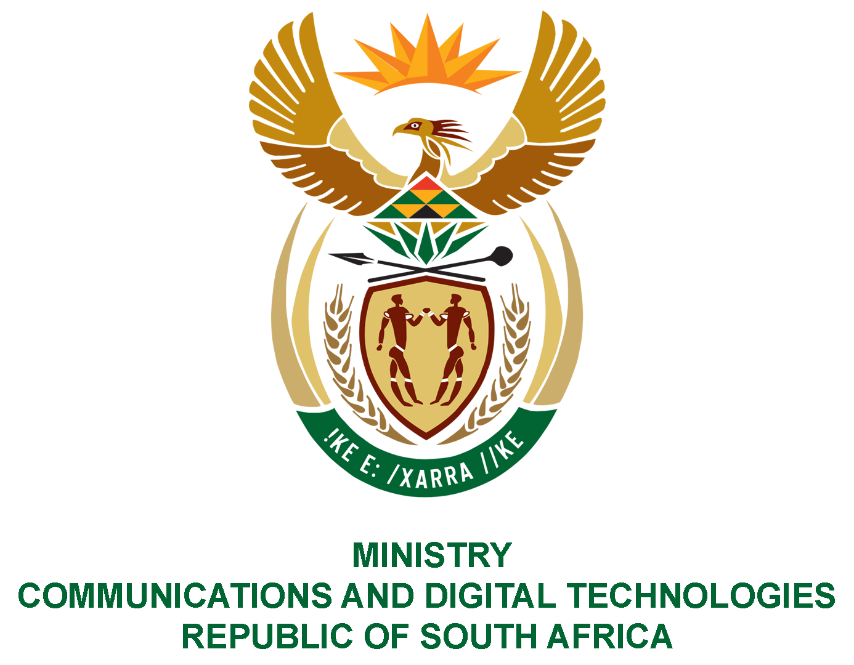

PARLIAMENT OF THE REPUBLIC OF SOUTH AFRICA
NATIONAL ASSEMBLY
WRITTEN REPLY

QUESTION NO: 739
DATE OF PUBLICATION: 01 May 2020
QUESTION PAPER NO: 13

Ms P T van Damme (DA) to ask the Minister of Communications:
Whether (a) she and (b) the Deputy Minister have undergone any training on media since she has been appointed to the Cabinet; if so, what (i) is the name of the service provider, (ii) was the total cost of the media training and (iii) number of sessions has completed?
NW943E
REPLY:

- Yes, the Minister did attend training on media.
          - This was an in-house training conducted by the GCIS.
          - There were no financial implications.
          - One session.

- Yes, the Deputy Minister did attend training on media.
          - This was an in-house training conducted by the GCIS.
          - There were no financial implications.
          - One session.

MR J MTHEMBU, MP
ACTING MINISTER OF COMMUNICATIONS AND DIGITAL TECHNOLOGIES

