DATE OF PUBLICATION OF INTERNAL QUESTION PAPER: 10/03/2023
INTERNAL QUESTION PAPER: 08/2023

737.. Dr W J Boshoff (FF Plus) to ask the Minister of Basic Education: to ask the Minister of Basic Education:

(1) As schools were divided into five quintiles according to the income of the communities where they are located a number of years ago, and as there were socio-economic shifts as well as school closures in the meantime, what is the current total number of schools in each quintile for each province;
(2) what was the budget for each of the quintiles for the 2021-22 financial year in each province;
(3) whether the quintiles ever get reviewed; if not, why not; if so, what are the relevant details?
Response

(1) As schools were divided into five quintiles according to the income of the communities where they are located a number of years ago, and as there were socio-economic shifts as well as school closures in the meantime, what is the current total number of schools in each quintile for each province;
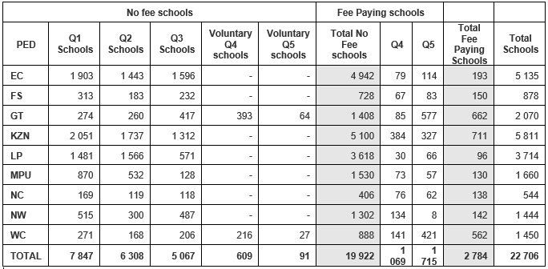
(2) what was the budget for each of the quintiles for the 2021-22 financial year in each province;
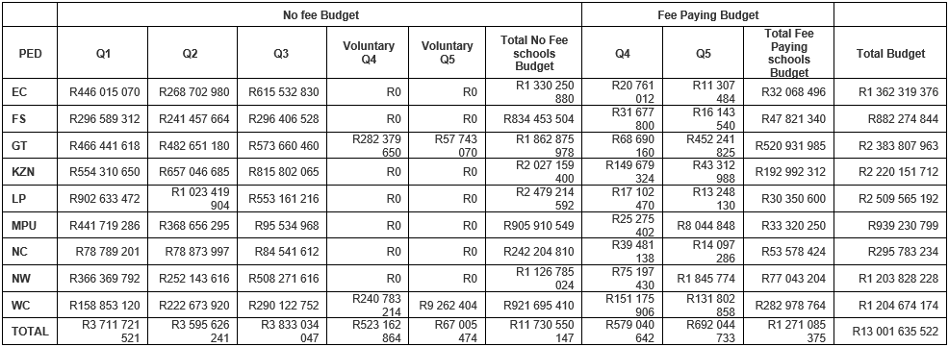
(3) whether the quintiles ever get reviewed; if not, why not; if so, what are the relevant details?
The Department of Basic Education (DBE) does not decide which quintile a school should be placed in. Schools are placed in quintiles by the Provincial Education Departments (PEDs). Paragraph 107 of the National Norms and Standards for School Funding state that PEDs must on an annual basis, subject to the availability of new data which is sufficiently reliable, consider reviewing the quintile of a school and make the necessary adjustments to effect equity. It is thus expected of all the PEDs to have a process in place that should be followed in their respective provinces to deal with this aspect. Such a process should allow the initiator to either be the school or the PED, depending on the circumstances.

