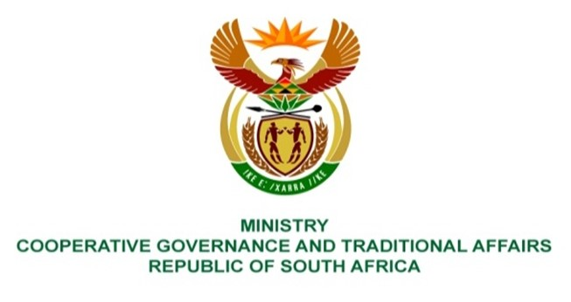

NATIONAL ASSEMBLY
QUESTIONS FOR WRITTEN REPLY
QUESTION NUMBER: 733

733. Mr B N Herron (Good) to ask the Minister of Cooperative Governance and Traditional Affairs:
Considering that point (p) in the National State of Disaster in Electricity Crisis regulations published in the latest Government Gazette makes specific reference to the increase in the requirements for water quality standards and capacity, specifically at the reservoirs and acknowledging that our water supply in a dry country is already at a breaking point with infrastructure collapse, most notably in Gauteng and throughout the Republic, (a) how do the specified regulation changes result in higher water quality and (b) what consequences will arise from any reservoirs and/or water infrastructure that does not meet the new standards? NO823E
REPLY:
This question can be responded to with the required detail and precision by the Department of Water and Sanitation, as the custodian of legislation and regulatory frameworks that govern provision of water. The role of the NDMC is to coordinate necessary activities aimed at mitigating the prospects of a total blackout, towards fulfilling the purpose outlined in section 27 (3) of the Disaster Management Act, 57 of 2002.
End.

