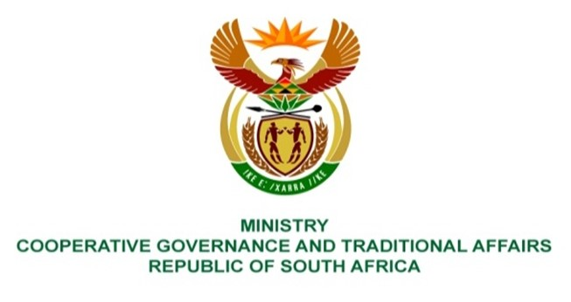

NATIONAL ASSEMBLY
QUESTIONS FOR WRITTEN REPLY

QUESTION NUMBER: 2021/733
DATE OF PUBLICATION: 05 MARCH 2021

QUESTION:

733. Mr C Brink (DA) to ask the Minister of Cooperative Governance and Traditional Affairs:
(1) In light of the fact that the report of the auditor-general noted that irregular expenditure in her department increased from R1,318 billion in 2019 to R1,330 billion in 2020, what corrective measures have been taken to address irregular expenditure;
(2) whether any person has been held accountable for her department’s failure to address irregular expenditure; if not, why not; if so, (a) who and (b) what action has been taken against the specified person(s)?

REPLY:
- The irregular expenditure cases are being investigated in line with the Irregular Expenditure Framework issued by the National Treasury in 2019. Upon finalization of these investigations, reports will be considered by the Loss Control and Asset Disposal Committee whereafter recommendations will be submitted to the Accounting Officer for further processing. At this stage, the department is not yet at the stage where it can concisely indicate how many cases will be recommended for condonement, and how many will be recommended for recovery in instances where loss was suffered by the department.

- The final determination of irregular expenditure and the related outcomes such as recovery, condonement and consequence management can only be concluded once the investigation reports are finalized. These reports are currently being finalized.

