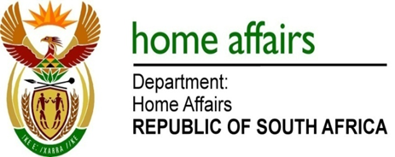

NATIONAL ASSEMBLY

QUESTION FOR WRITTEN REPLY

QUESTION NO. 730

DATE OF PUBLICATION: Friday, 24 March 2017

INTERNAL QUESTION PAPER 11 OF 2017

730. Mr A M Figlan (DA) to ask the Minister of Home Affairs:

In view of the indication from the National Treasury that the Border Management Authority Bill [B9-2016] may not be fully funded in its proposed form, what changes will be needed in the migration policy? NW789E
REPLY:

The Department of Home Affairs is not aware of the indication by National Treasury that the Border Management Authority Bill [B9-2016] may not be fully funded in its proposed form.

Since the BMA is envisaged to be an implementation organ of state in the border environment no immediate migration policy changes are foreseen as a result of the BMA’s establishment. The White Paper process on International Migration is at an advanced stage and it already makes provision for and supports the establishment of a BMA.

