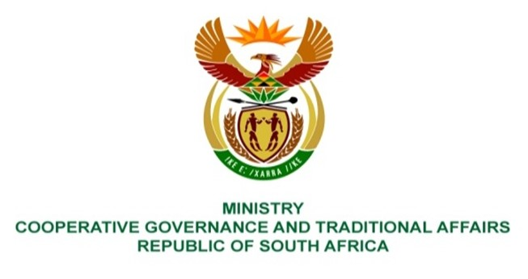

NATIONAL ASSEMBLY
QUESTION FOR WRITTEN REPLY

QUESTION NUMBER: 73

73. Mr C Brink (DA) to ask the Minister of Cooperative Governance and Traditional Affairs:
Whether she has ever met two certain persons (names furnished) and/or any other person who is or has been a director, associate and/or employee of a certain company (name furnished) and/or any company trading under the name of the specified company; if not, what is the position in each specified case; if so, in each case, (a)(i) on what date and (ii) where did each such meeting take place, (b) who was present at each meeting and (c) what was discussed at each meeting? NW73E

REPLY:

The question be referred to the Minister in the Presidency for Women, Youth and Persons with Disabilities, precisely because it is asked on her personal capacity.
End.

