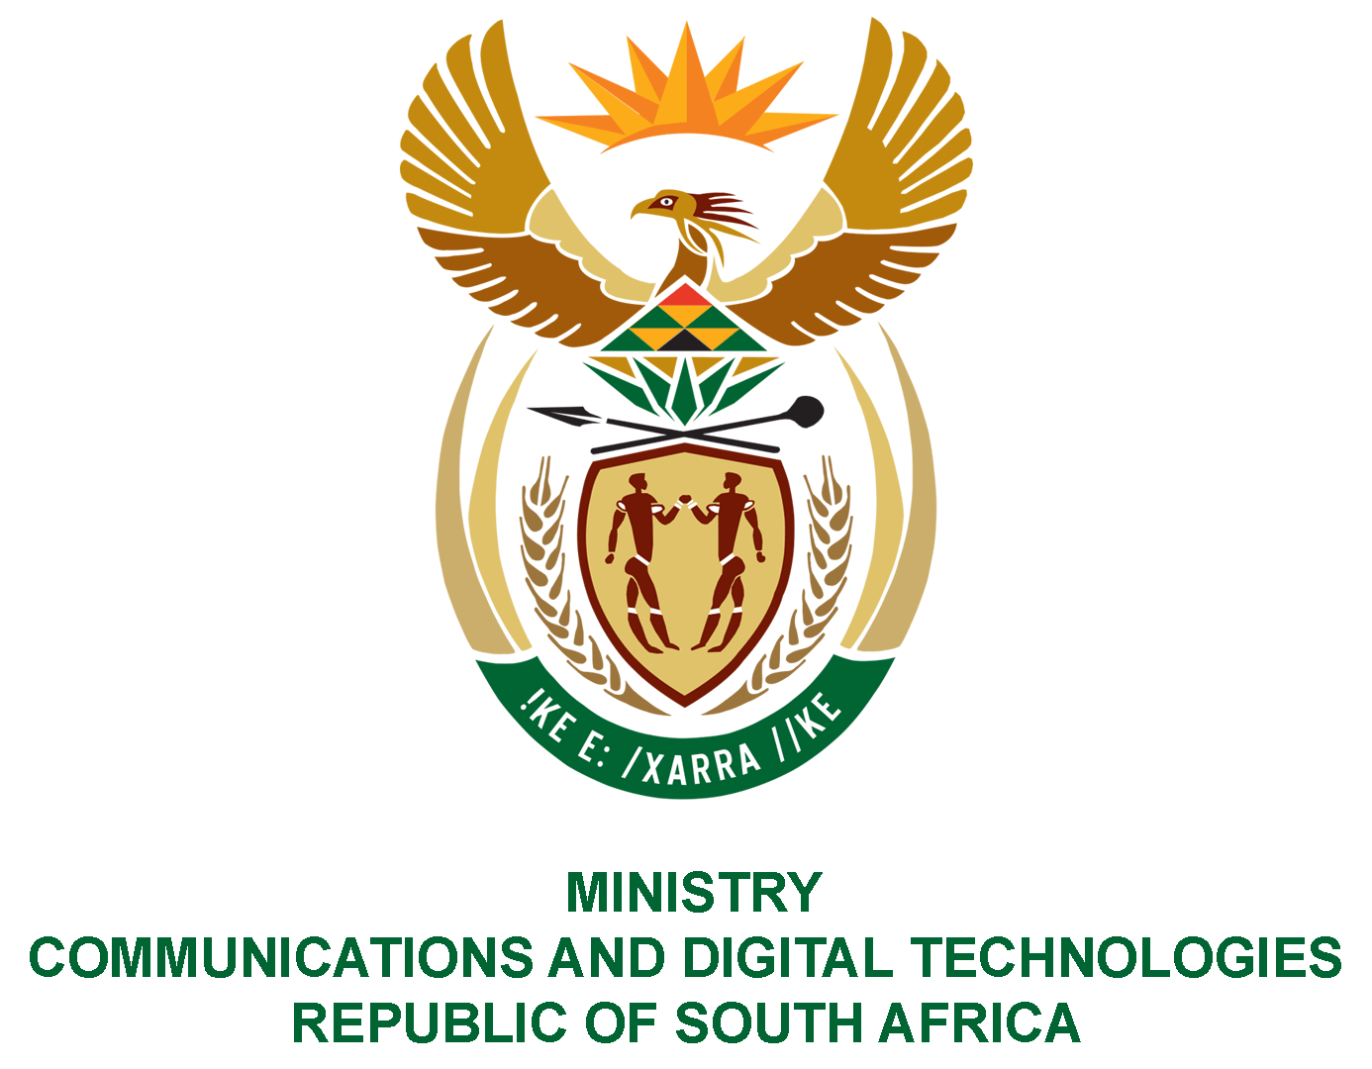

PARLIAMENT OF THE REPUBLIC OF SOUTH AFRICA

NATIONAL ASSEMBLY

WRITTEN REPLY
QUESTION NO: 729
DATE OF PUBLICATION: 1 April 2022
QUESTION PAPER NO: 13
DATE OF REPLY:
Mr W W Wessels (FF Plus) to ask the Minister of Communications and Digital Technologies: [Interdepartmentally transferred from Cooperative Governance and Traditional Affairs with effect 31 March 2022]
(1) What are the total outstanding amounts owed by the SA Post Office to (a) each local authority and (b) each province for services as at the latest specified date for which information is available;
(2) Whether any steps are being taken to recover the outstanding monies; if not, why not; if so, what are the relevant details;
(3) Whether she will make a statement on the matter? NW868E

REPLY:
I have been advised by the SAPO as follows:
1.
(a) The only local authority that SAPO owes is Buffalo City Metropolitan Municipality in the Eastern Cape. The amount outstanding is R 237,256.83 and will be settled in full on 15 April 2022.
(b) All other local authority accounts are up to date.
(2) SAPO is recovering all outstanding utilities amounts from Telkom
(3) No statement will be made on the matter.

Authorised for submission by

MS. NONKQUBELA JORDAN-DYANI
DIRECTOR-GENERAL (ACTING)
DATE:

Recommended/not recommended

__________________________
HON. PHILLY MAPULANE, MP
DEPUTY MINISTER OF COMMUNICATIONS AND DIGITAL TECHNOLOGIES
DATE:

Approved/ not approved

________________________________
HON. KHUMBUDZO NTSHAVHENI, MP
MINISTER OF COMMUNICATIONS AND DIGITAL TECHNOLOGIES
DATE:

