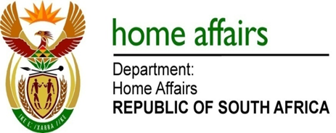

NATIONAL ASSEMBLY

QUESTION FOR WRITTEN REPLY

QUESTION NO. 729

DATE OF PUBLICATION: Friday, 24 March 2017

INTERNAL QUESTION PAPER 11 OF 2017

729. Mr A M Figlan (DA) to ask the Minister of Home Affairs:

Given the imperative to move towards liberalising regional and continental migration as envisaged in the African Union’s Vision 2063, what more has he found can be done to harmonise the various Southern African migration laws in a way that fairly shares financial and social benefits and burdens between countries?
NW788E
REPLY:

In order for progress to be made on this matter various regional blocks within the continent as well as the African Union (AU) are considering the terms of Agenda 2063 to see how the objectives can be realised. Currently various experts on immigration from within the region and continent are discussing the technical aspects and other matters in relation to this. It is envisaged that a harmonised position will eventually be considered at a heads of state summit level.

