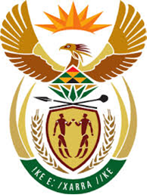

DEPARTMENT: PUBLIC ENTERPRISES
REPUBLIC OF SOUTH AFRICA

NATIONAL ASSEMBLY

726. Mr M M Dlamini (EFF) to ask the Minister of Public Enterprises:
What is the (a) make and (b) year of production of every aircraft in the SA Airways fleet? NW849E
Reply:

The Parliamentary question has been forward to South African Airways and the Department and the Ministry of Public Enterprises awaits their response. Further information will be conveyed to Parliament as soon as the response is received.

