NATIONAL ASSEMBLY
WRITTEN REPLY

QUESTION 725

INTERNAL QUESTION PAPER [No 6-2021 SIXTH PARLIAMENT]
DATE OF PUBLICATION: 05 MARCH 2021

725. Mrs A Steyn (DA) to ask the Minister of Agriculture, Land Reform and Rural Development:

- Whether her department was responsible for identifying beneficiaries for the stimulus support that was provided as part of the COVID-19 packages; if not, (a) who was responsible to identify the beneficiaries and (b) what criteria were used;

(2) whether she will furnish Mrs A Steyn with the report that was produced in order to motivate for support packages of identified beneficiaries; if not, why not; if so, on what date? NW846E

THE MINISTER OF AGRICULTURE, LAND REFORM AND RURAL DEVELOPMENT:

- Yes, the Department of Agriculture, Land Reform and Rural Development (DALLRD) was responsible for identifying the Presidential Employment Stimulus Initiative (PESI) through an application process.

(a) Falls away.

(b) The Criteria used was dealt with in three distinct parts:
A: Compulsory Criteria;
B: Functional Criteria; and
C: Verification Criteria.

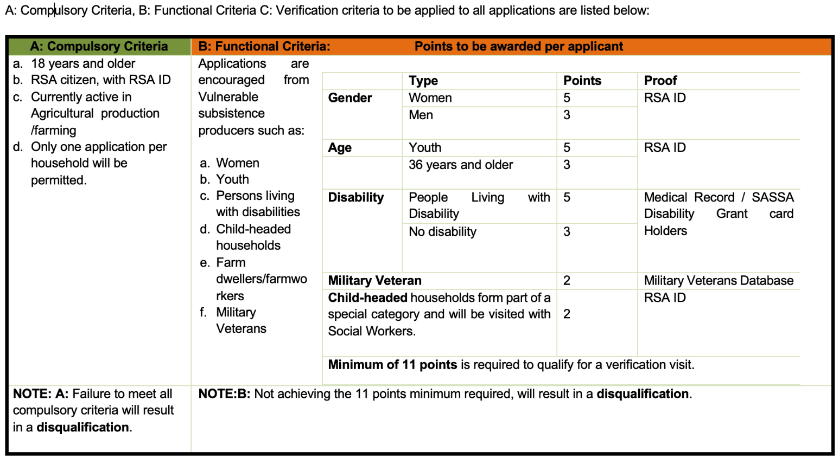
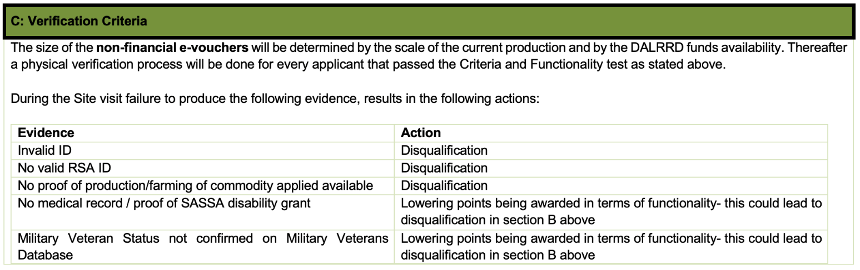

(2) Yes. The information on support packages is provided below. The support packages to subsistence producers was determined by the agricultural economists based on the following production sizes:

Commodity | Production size required for support
Vegetable and fruit | 1 ha or smaller (smaller than 100 meters x 100 meters or one soccer field);
Maize/soya/cotton/sugar/ grain products/ other | 1ha or smaller (smaller than 100 meters x 100 meters or one soccer field)
Poultry | Broilers | 100 broilers or less
 | Layers | 50 layers or less
Livestock | Small Stock Units | 25 animals or less
 | Large Stock Units | 5 animals or less
NOTE:
- Award sizes will range between R1000 and R9000, and are dependent on the commodity type applied for and verified production scale.
- The size of the non-financial e-voucher will be determined by the current scale of production after physical verification by the Department of Agriculture Land Reform and Rural development.

** Please note the verification process in underway **

Section C below unpacks the production sizes further.

