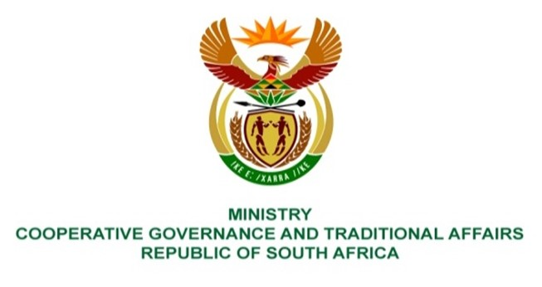

NATIONAL ASSEMBLY
QUESTIONS FOR WRITTEN REPLY
QUESTION NUMBER: 724

724. Mrs G Opperman (DA) to ask the Minister of Cooperative Governance and Traditional Affairs:
What steps has her department taken to assist failing municipalities as provided for in the Constitution of the Republic, 1996, to improve (a) service delivery and (b) financial administrative capacities? NO807E
REPLY:
- Steps taken to improve service delivery capacities.
Municipal Infrastructure Support Agent (MISA) has deployed built environment professionals to municipalities in accordance with the District Development Model (DDM) to provide technical support for infrastructure development throughout the product life cycle from inception, planning, design development, implementation, operations and maintenance. This aims to augment and build State Capacity. 103 Built environment professionals (86 of which are professionally registered with Statutory bodies as engineers and town planners). In the current financial year, 150 Young Graduates have been deployed to augment the technical capacity whilst pursuing professional registration. These technical professionals support municipalities to implement infrastructure grant programmes that include the Municipal Infrastructure Grant (MIG) administered by the Department of Cooperative Governance (DCOG), the Water Services Infrastructure Grant (WSIG) and the Regional Bulk Infrastructure Grant (RBIG) which are both administered by the Department of Water and Sanitation (DWS) as well as the Integrated National Electrification Programme (INEP) administered by the Department of Mineral Resources and Energy (DMRE). The budget allocations are published annually in the Division of Revenue Act (DORA). These technical professionals also support municipalities to employ and maximise labour intensive construction (LIC) methods where feasible, by incorporating the Expanded Public Works Programme (EPWP) Guidelines during infrastructure development e.g. low volume roads, water, sanitation and electrification projects. The use of LIC methods during infrastructure development maximises the creation of job opportunities thereby alleviating unemployment. This will assist municipalities to meet the job opportunities target for the EPWP infrastructure sector administered by the Department of Public Works and Infrastructure (DPWI).

- MISA is implementing capacity building programmes aimed at building the capacity of municipalities for infrastructure development. These capacity building programmes aim at the current cohort of municipal officials as well as unemployed youth by creating a skills pipeline.

- The municipal officials responsible for infrastructure development are trained through short courses for continuous professional development throughout the project life cycle as well as taking them through a Recognition of Prior Learning (RPL) programme. MISA is providing training on short technical courses in collaboration with the South African Institute of Civil Engineers (SAICE) and aims to train 500 officials this financial year. The RPL programme involves assessment, training provisioning and attaining a qualification of those municipal officials who gained work experience but did not get formal qualifications. MISA aims to enrol 100 officials for RPL Programme.

- The capacity building programmes implemented that are targeting unemployed youth are the Apprenticeship Programme, the Experiential Learnership Programme, the Bursaries Programme and the Young Graduates Programme. The implementation is done in collaboration with the Local Government Sector Education and Training Authority (LGSETA). MISA aims to enrol a total of 420 youths for these skills programmes for this financial year. The respective targets are 100 for Apprenticeship Programme, 70 for the Experiential Learnership Programme, 100 for the Bursaries Programme and 150 for the Young Graduates Programme.

- MISA has implemented other capacity building initiatives for municipalities to provide infrastructure development viz. the building of internal built environment design development capacity so that there is less reliance on outsourcing to Consultants, the development of Public Infrastructure Unit Cost Guidelines as well as collaboration with professional bodies and Institutions of Higher Learning.

- MISA has bought design software and is currently piloting the establishment of a design office at OR Tambo District Municipality where selected infrastructure projects that are prioritised and funded by the municipality are designed through the support of MISA procured design software and technical support personnel and not outsourced to Consultants.

- The Unit Cost Guidelines were developed in collaboration with the University of Cape Town. These Guidelines provide cost estimates of providing infrastructure as one source of truth for planning, budgeting and implementation monitoring. The Guidelines can be used by all interested and affected stakeholders including municipalities, communities, oversight structures and law enforcement agencies. The Guidelines assist in building communities’ confidence in government expenditure on infrastructure development. The Unit Cost Guidelines were used during the assessment of municipal infrastructure that was damaged by floods in April 2022.

- MISA has entered into a collaboration agreement with the University of Cape Town and Wits University and is finalizing a Memorandum of Agreement with the Engineering Council of South Africa (ECSA). The collaborations with these institutions aim to use research to find innovative solutions to infrastructure development and service delivery challenges among other benefits.

- MISA is also contributing towards the eradication of basic services backlogs through its meagre budget by funding and implementing 39 borehole projects in this financial year in low and medium capacity municipalities.

- MISA, through DCOG, applied for the Presidential Employment Stimulus (PES) program that was aimed at addressing the devastating impact of COVID-19 on the economy to an amount of about R700 million. An amount of R284 million was approved for MISA to implement the PES through the Innovative Solid Waste Management Program that was piloted in 25 municipalities across the 9 provinces.

The project commenced in December 2021. To-date the programme has created employment opportunities as detailed below as the programme ensured removal of municipal waste:

Province | Number of municipalities benefitted | Number of jobs created | Amount spent
Eastern Cape | 7 | 3 200 | R51 252 295.00
Free State | 4 | 1 996 | R38 134 654. 50
Gauteng | 4 | 1200 | R20 488 113.15
KwaZulu Natal | 9 | 4 400 | R64 977 015.00
Limpopo | 3 | 1 500 | R21 854 087.7
Mpumalanga | 2 | 1 038 | R14 569 391.90
Northern Cape | 5 | 1200 | R23 458 589. 68
North West | 4 | 1 200 | R26 426 925.00
Western Cape | 3 | 900 | R22 496 929. 95
TOTAL | 41 | 16 634 | R 283 658 001.88
The participants were employed for a period of (16 weeks) 3 months and received a minimum stipend of R102 per day for general workers, and R150 per day for coordinators.
End.

