PRIVATE BAG x 1000, PRETORIA, 0001, Tel: 082 677 2593

Memorandum from the Parliamentary Office Minister
National Assembly question for written reply: 723

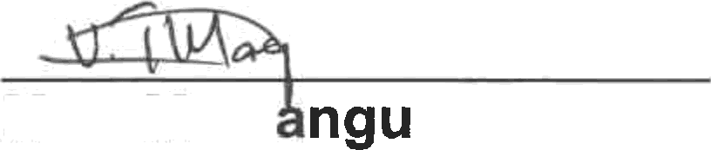

Mr E Mahl
D: Auxiliary
Date:»r)«7} sol4

Supported /Not Supported
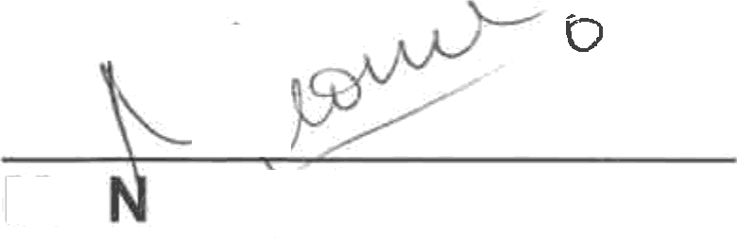
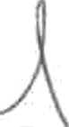
Ms
Ng§stunga
ACD:CM

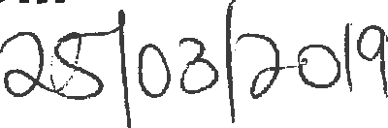
Date:

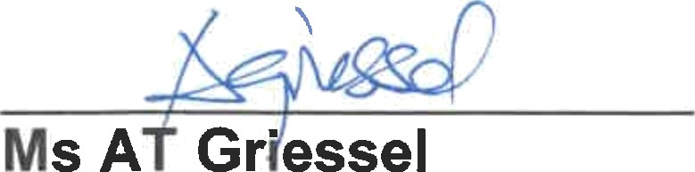
Recommende end

Ms A Gr"essel
Acting Director-General Date: ¿ggg (<s(

NATIONAL ASSEMBLY QUESTION FOR WRITTEN REPLY QUESTION NUMBER: 723

DATE OF PUBLICATION IN INTERNAL QUESTION PAPER: 15 MARCH 2019
INTERNAL QUESTION PAPER NUMBER: 08 - 2019

Mr C D Matsepe (DA) to ask the Minister of Women in The Presidency:
What is the (a) make, (b) model, (c) price and (d) date on which each vehicle was purchased for use by her and/or the former minister (i) in the (aa) 2016-17 and (bb) 2017-18 financial years and (ii) since 1 April 2018? NW846E

Reply:
The Department did not purchased any vehicle(s) for use by the Minister in the 2016-17, 2017-18 and 2018-19 financial years.

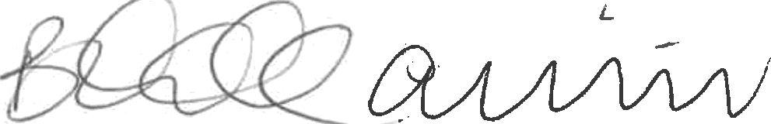

Minister on

