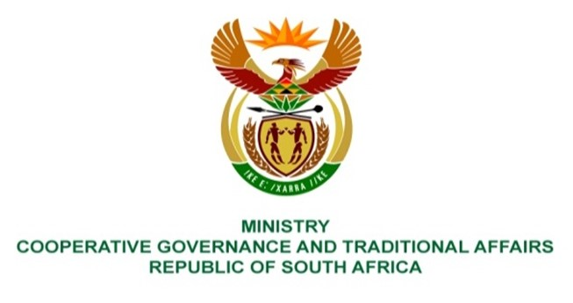

NATIONAL ASSEMBLY
QUESTIONS FOR WRITTEN REPLY
QUESTION NUMBER: 722

722. Ms E R J Spies (DA) to ask the Minister of Cooperative Governance and Traditional Affairs:
Whether her department has conducted any studies, evaluations and/or investigations to determine the feasibility of consolidating the various Public Employment Programmes of her department with regard to local government and traditional affairs to minimize resource wastage and expenditure on administrative costs; if not, what is the position in this regard; if so, what are the relevant details? NO805E
REPLY:
Regarding the consolidation of state employment programs, no evaluation has been conducted. This is because the department only has one program for public work, the Community Works Program. Since the agency oversees a number of Public Employment Programs, the Parliamentary Question ought to be directed to the Minister of Public Works.
End.

