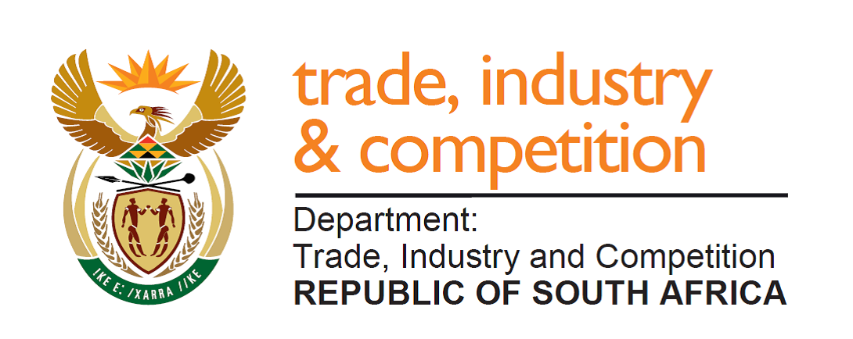

NATIONAL ASSEMBLY

WRITTEN REPLY

PARLIAMENTARY QUESTION 722

DATE OF PUBLICATION: 30 AUGUST 2019

Mr H C C Kruger (DA) to ask the Minister of Trade and Industry
Whether his department has invested or intends to invest money in the Highveld Industrial Park near Emalahleni in Mpumalanga; if so, (a) what amount (i) was spent in the previous financial year and (ii) does his department intend to spend in the next financial year, (b) what number of (i) new businesses are assisted and (ii) new jobs are created in the project and (c) what (i) development and (ii) support measures is his department planning for entrepreneurs who are interested to start-up businesses in the industrial park? NW1767E
Reply:

The departments of Trade and Industry and Economic Development have not invested money in the Highveld Industrial Park. The Industrial Development Corporation (IDC) provided loan funding to the structural steel mill located at Highveld Industrial Park during Business Rescue.

The Industrial Park currently has 51 tenants and 1 141 are jobs created.

Government through the IDC, sefa and the various incentive schemes on offer will consider suitable support upon request from individual businesses planning to locate or those that are located at the industrial park.

-END-

