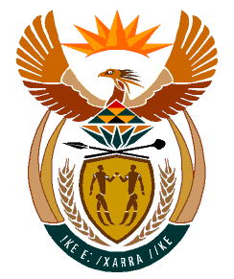

MINISTRY:
HUMAN SETTLEMENTS, WATER AND SANITATION
REPUBLIC OF SOUTH AFRICA

NATIONAL ASSEMBLY

QUESTION FOR WRITTEN REPLY

QUESTION NO.: 718

DATE OF PUBLICATION: 1 MAY 2020

Ms B M van Minnen (DA) to ask the Minister of Human Settlements, Water and Sanitation:
In view of the fact that the annual report of the Department of Water and Sanitation that should have been submitted on 30 August 2019 was seven months late and necessitated an investigation by the Standing Committee on Public Accounts, what steps has she taken to ensure that the annual report which is due 2020 will not also be similarly delayed? NW922E

REPLY
The Department of Water and Sanitation has taken all the necessary steps to address the challenges that resulted in the late submission of the 2018/19 Annual Report to Parliament. The 2019/20 Annual Report will be tabled in accordance with the legislated timeframe.

