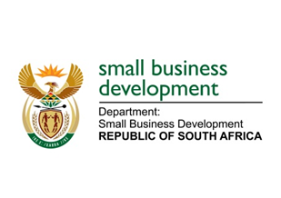
NATIONAL ASSEMBLY

QUESTION FOR WRITTEN REPLY

“716. Mr Z N Mbhele (DA) to ask the Minister of Small Business Development:

What measures and mechanisms did her department put in place and is implementing to enable, promote and expand small business access to equity financing?”
NW1761E

REPLY:

Improving investment readiness is key to both debt and equity financing. The Department through its entities has a number of programmes that aimed at ensuring that SMMEs are enabled to access equity financing. We have incubation programmes that we are implementing through Seda where we provide structured training on both technical and soft skills to SMMEs. There is also a mentorship programme that is offered through Seda where we get skilled individuals to offer mentorship support to SMMEs. The agency also runs an investor pitching initiative called “Pitch & Perfect”, to close the large gap between what entrepreneurs present and what investors are looking for.

According to the Global Entrepreneurship Index, South Africa has higher innovation than the world average, but low risk capital and low start-up skills. Pitch & Perfect addresses these gaps, by providing annual seasons of both pitching masterclasses and pitching competitions at provincial and national level, to promote and enable investment readiness.

Through sefa, upon disbursement, if a client needs business support, sefa immediately assigns a mentor for a period of up to 12 months at sefa’s cost. In addition, sefa has an agreement with South African Institute of Chartered Accountants (SAICA) to assist eligible sefa clients with management accounts at no cost to sefa clients.
_______________________________________________________________________________

