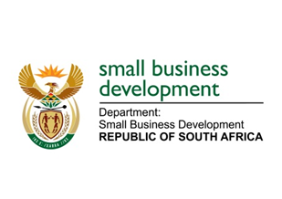
NATIONAL ASSEMBLY

QUESTION FOR WRITTEN REPLY

“715. Mr Z N Mbhele (DA) to ask the Minister of Small Business Development:

What measures and mechanisms did her department put in place and is implementing to enable, promote and expand small business access to private sector credit from commercial banks, specifically by having the State acting as surety and/or providing debt financing as collateral for eligible small, medium and micro enterprises?
NW1760E

REPLY:

As announced during our tabling of the Department's Annual Performance Plan (2019/2020, the Department has adopted a new operational model which includes Access to Finance as a full programme. This programme extends to risk cover and business rescue, SMME contracting models, SMME payments, Common Application Templates, Blended Funding, SMME Funding Policy, financial sustainability and innovative funding facilities. These Initiatives will progressively be rolled out throughout the next five years jointly with the private sector. Currently the credit guarantee scheme which is called Khula Credit Guarantee Scheme that is implemented through sefa is in partnership with the private sector. This scheme offers guarantee to lenders on behalf of SME borrowers who would otherwise have their access impeded by the lack of collateral required by various financiers. We intend to upscale this programme as part of expanding various funding options for SMEs.

