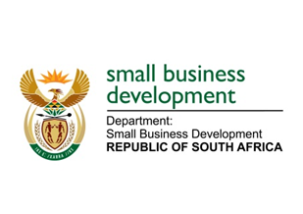
NATIONAL ASSEMBLY

QUESTION FOR WRITTEN REPLY

“715. Ms T M Mbabama (DA) to ask the Minister of Small Business Development:

What is the (a) make, (b) model, (c) price and (d) date on which each vehicle was purchased for use by (i) her and (ii) her deputy (aa) in the (aaa) 2016-17 and (bbb) 2017-18 financial years and (bb) since 1 April 2018?”
NW838E

REPLY:
aaa. Details of the vehicles purchased for use by the Minister and Deputy Minister for 2016/2017
NO | ITEM | (i) MINISTER | (ii)DEPUTY MINISTER
a. | Make | Lexus | Volvo
b. | Model | GS350 | XC90
c. | Price | R538 048.08 | R659 728.51
d. | Date of purchase | 17 September 2014 | 27 September 2011

NO | ITEM | (i) MINISTER | (ii)DEPUTY MINISTER
a. | Make | Lexus | Volvo
b. | Model | GS350 | XC90
c. | Price | R542 458.74 | R855 696.36
d. | Date of purchase | 02 December 2014 | 24 January 2014

bbb. Details of the vehicles purchased for use by the Minister and Deputy Minister for 2017/2018
NO | ITEM | (i) MINISTER | (ii)DEPUTY MINISTER
a. | Make | BMW | BMW
b. | Model | 540i | 540i
c. | Price | R944 376.80 | R874 876.80
d. | Date of purchase | 20 December 2017 | 20 December 2017

bb. No vehicles were purchased for the Minister and Deputy Minister during the 2018/2019 financial

