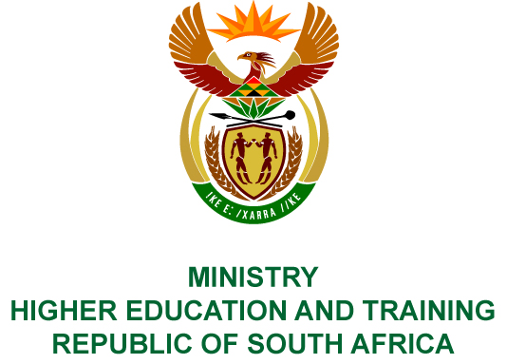
Private Bag X893, Pretoria, 0001, Tel (012) 312 5555, Fax (012) 323 5618
Private Bag X9192, Cape Town, 8000, Tel (021) 469 5150, Fax: (021) 465 7956
Memorandum from the Parliamentary Office
NATIONAL ASSEMBLY
FOR WRITTEN REPLY
QUESTION 714
DATE OF PUBLICATION OF INTERNAL QUESTION PAPER: 20/03/2018
(INTERNAL QUESTION PAPER NO 6 OF 2018)
Mr D J Stubbe (DA) to ask the Minister of Higher Education and Training:
(1) Whether her department has a sexual harassment and assault policy in place; if not, (a) why not and (b) by what date will her department have such a policy in place; if so, (i) how are reports investigated and (ii) what are the details of the consequence management and sanctions stipulated by the policy;
(2) (a) what is the total number of incidents of sexual harassment and assault that have been reported in her department (i) in each of the past three financial years and (ii) since 1 April 2017, (b) what number of cases were (i) opened and concluded, (ii) withdrawn and (iii) remain open based on the incidents and (c) what sanctions were issued for each person who was found to have been guilty?
NW788E
REPLY:
- (a) The Department has a sexual harassment policy.
- Cases are managed through a multi-disciplinary team that consists of an official from the Employee Health and Wellness Unit for counselling purposes and an appointed official from the Labour Relations Unit to conduct an investigation and to initiate a disciplinary enquiry.
- The Presiding Officer uses his or her discretion based on the facts and evidence presented by both the complainant and alleged perpetrator before determining a sanction.
- (a) The total number of sexual harassment and assault cases reported in the Department are as follows:
- In the 2014/15 financial year, there were no cases reported.
- In the 2015/16 financial year, there were seven reported cases.
- In the 2016/17 financial year, there were three reported cases.
- Since April 2017 to date, two cases have been reported.
(b) (i) Two cases are open and ten cases were concluded.
(ii) Out of the ten cases that were concluded, one case was withdrawn.
(iii) Two cases remain open and the enquiries are still in progress.
(c) The sanctions issued to individuals found guilty were four dismissals, four written warnings and one employee resigned before the sanction was issued.

