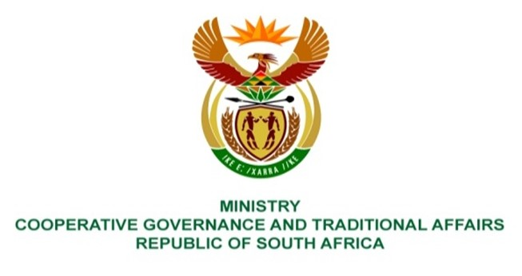

NATIONAL ASSEMBLY
QUESTIONS FOR WRITTEN REPLY
QUESTION NUMBER: 711

711. Ms H O Mkhaliphi (EFF) to ask the Minister of Cooperative Governance and Traditional Affairs: -
(a) What direct interventions were made to provide relief to the persons affected by the recent floods in the Republic and (b) how will the lessons learnt from the response to the floods that affected KwaZulu-Natal in 2022 guide her department to improve its response to natural disasters of this nature? NO784E
REPLY:
- Direct interventions made by the Department to provide relief to the persons affected by the recent floods are made through the National Disaster Management Centre (NDMC) coordinated and collaborated with relevant stakeholders on disaster intervention measures as per its legislated mandate. The following are actions by the department:
- Facilitated the deployment of teams from the Security Cluster for search and rescue missions within the affected communities. Coordinated the evacuation missions and placement of affected households within emergency shelters. Mobilised humanitarian relief measures and the distribution by stakeholders within affected communities. Facilitated technical support to municipalities through the Municipal Infrastructure Support Agent (MISA) in addressing some of the critical infrastructure damages for the restoration of services. Monitored conditions on the ground, further disseminated early warnings and advisories for informed decisions to prevent the conditions from deteriorating further within communities. Allocated disaster grant funding to affected municipalities for disaster interventions to address the damages incurred by municipalities and monitored implementation of interventions and provide support to municipalities to enhance the realisation of desired impacts from allocated funding.
- The department continues to incorporate the lessons learnt within the disaster management function. The disaster grant frameworks were amended to factor in the lessons learned. Currently, the department is leading in the review of the Disaster Management system in consultation with relevant stakeholders to ensure collation of and implementation of lessons learnt to enhance the current system.
End.

