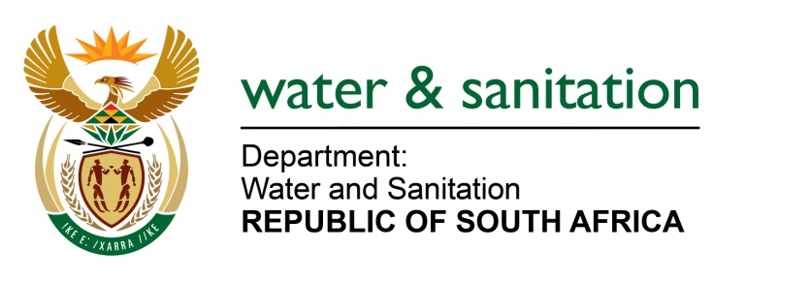

NATIONAL ASSEMBLY

FOR WRITTEN REPLY

QUESTION NO 711

DATE OF PUBLICATION IN INTERNAL QUESTION PAPER: 17 MARCH 2017
(INTERNAL QUESTION PAPER NO. 10)
711. Mr G R Krumbock (DA) to ask the Minister of Water and Sanitation:
(1) Did (a) her department or (b) any entity reporting to her participate in the Dialogue with the President: Unpacking of the SONA 2017 on Radical Economic Transformation Implementation event hosted at the Oyster Box Hotel in Umhlanga, Durban, on 25 February 2017; if so, what amount was spent in each case;

(2) did (a) her department or (b) any entity reporting to her participate in the auction of the (i) souvenirs or (ii) personal belongings of the President of the Republic, Mr Jacob G Zuma; if so, (aa) which items were purchased and (bb) at what cost, in each case? NW770E
---00O00---
REPLY:

(1) No, neither my Department nor any Entities reporting to me participated in the Dialogue with the President: Unpacking of the SONA 2017 on Radical Economic Transformation Implementation event hosted at the Oyster Box Hotel in Umhlanga, Durban, on 25 February 2017.
(2) No, neither my Department nor any Entities reporting to me participated in the auction of the souvenirs, personal belongings of the President of the Republic Jacob G Zuma.
---00O00---

