FOR WRITTEN REPLY QUESTION 710

NATIONAL ASSEMBLY
36/1/4/1(201900082)

DATE OF PUBLICATION IN INTERNAL QUESTION PAPER: 15 MARCH 2019 fINTERNAL QUESTION PAPER NO 8-2019)

710. Mr S C Motau (DA) to ask the Minister of Police:

What is the (a) make, (b) model, (c) price and (d) date on which each Vehicle was purchased for use by (i) him and/or the former minister and (ii) his deputy and/or former deputy minister (aa) in the (aaa) 2016-17 and (bbb) 2017-18 financial years and (bb) since 1 April 2018?
NW833E
REPLY:

A total of four vehicles were procured for the office of the Ministry of Police during the 2017/2018 financial year:

(a)(b)(c) and (d) The details are as follows:

Number of (a) Make vehicles
Model (c) Total Prce (d) Date

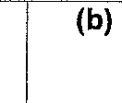
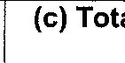
Four BMW 30d R3 528 025,02018-03-2D
(b)

(i) and (ii) The four vehicles, as reflected in the table above, were purchased for the current Minister of Police and the current Deputy Minister of Police.

(aa)(aaa) In 2016/2017, no vehicles were purchased for the Minister or the Deputy Minister of Police.

(aa)(bbb) In 2017/2018, four vehicles were purchased, as reflected in the table above.

(bb)
Since 1 April 2018, no vehicles were purchased for the Minister or the Deputy Minister of Police.

2

Reply to question 710 recommended/

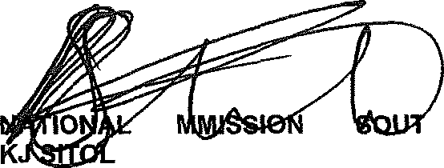
GENERAL AFRICAN POLICE SERVICE
cO
E (SOEG)
ER:
H

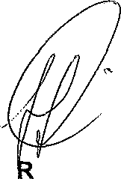
Reply to question 710 approved/ pp o ed

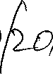
MINISTE OF POLICE BH CELE, MP
Date: .

