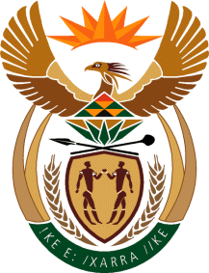

MINISTRY OF TOURISM
REPUBLIC OF SOUTH AFRICA

Private Bag X424, Pretoria, 0001, South Africa. Tel. (+27 12) 444 6780, Fax (+27 12) 444 7027
Private Bag X9154, Cape Town, 8000, South Africa. Tel. (+27 21) 469 5800, Fax: (+27 21) 465 3216

Ref: TM 2/1/1/10

NATIONAL ASSEMBLY:

QUESTION FOR WRITTEN REPLY:
Question Number: 708
Date of Publication: 17 March 2017
NA IQP Number: 10
Date of reply: 31 March 2017

Ms SP Kopane (DA) to ask the Minister of Tourism:
(1) Did (a) his department or (b) any entity reporting to him participate in the Dialogue with the President: Unpacking of the SONA 2017 on Radical Economic Transformation Implementation event hosted at the Oyster Box Hotel in Umhlanga, Durban, on 25 February 2017; if so, what amount was spent in each case;
(2) did (a) his department or (b) any entity reporting to him participate in the auction of the (i) souvenirs or (ii) personal belongings of the President of the Republic, Mr Jacob G Zuma; if so, (aa) which items were purchased and (bb) at what cost, in each case? NW767E
Reply:

- (a) No, the Department did not participate.

- (a) No, the Department did not participate.

Souvenirs | Personal belongings
(i) No | (i) No
(aa) Not applicable | (aa) Not applicable
(bb) Not applicable | (bb) Not applicable

- (b) No, SA Tourism did not participate.

- (a) No, SA Tourism did not participate.

Souvenirs | Personal belongings
(i) No | (i) No
(aa) Not applicable | (aa) Not applicable
(bb) Not applicable | (bb) Not applicable

