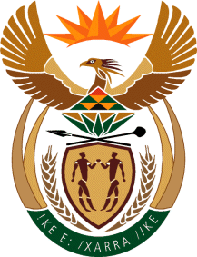
MINISTRY: SPORT AND RECREATION
REPUBLIC OF SOUTH AFRICA

Private Bag X869, Pretoria, 0001, Tel: (012) 304 5053, Fax: (012) 323 8426
Private Bag X9149, Cape Town, 8000, Tel: (021) 465 5506/7/8/9, Fax: (021) 465 4402
_____________________________________________________________________

NATIONAL ASSEMBLY

WRITTEN REPLY

705. Mrs S V Kalyan (DA) to ask the Minister of Sport and Recreation:
(1) Did (a) his department or (b) any entity reporting to him participate in the Dialogue with the President: Unpacking of the SONA 2017 on Radical Economic Transformation Implementation event hosted at the Oyster Box Hotel in Umhlanga, Durban, on 25 February 2017; if so, what amount was spent in each case;
(2) did (a) his department or (b) any entity reporting to him participate in the auction of the (i) souvenirs or (ii) personal belongings of the President of the Republic, Mr Jacob G Zuma; if so, (aa) which items were purchased and (bb) at what cost, in each case? NW764E
________________________________________________________________
The Minister of Sport and Recreation
REPLY:

(1) (a) and (b) No.

(2) (a) and (b) No. the Department of Sport and Recreation South Africa did not participate in the said auction; thus (i) and (ii), (aa) and (bb) fall away.

