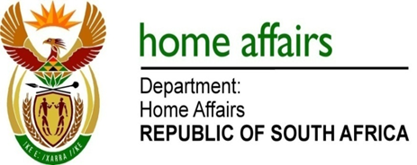

NATIONAL ASSEMBLY

QUESTION FOR WRITTEN REPLY

QUESTION NO. 703

DATE OF PUBLICATION: 15, FRIDAY, MARCH 2019

INTERNAL QUESTION PAPER 8 OF 2019

703. Mr M H Hoosen (DA) to ask the Minister of Home Affairs:

What is the (a) make, (b) model, (c) price and (d) date on which each vehicle was purchased for use by (i) him and/or the former minister and (ii) his deputy and/or former deputy minister (aa) in the (aaa) 2016-17 and (bbb) 2017-18 financial years and (bb) since 1 April 2018? NW826E

REPLY:

I have been informed by my Department as follows:

(a)(b)(c)(d)(i)(ii)(aa)(aaa) No Vehicles were purchased for the Minister in the 2016/2017 financial year.

(a)(b)(c)(d)(i)(aa)(bbb) (a) Lexus (b) RX 350 EX (c) R815 660.88 (d) September 2017 (bbb) 2017-18 financial year.
(a)(b)(c)(d)(i)(aa)(bbb) AUDI (b) Q7 3.0 TDi, (c) R847 676.64 (d) September 2017 (bbb) 2017-18 financial year.

a)(b)(c)(d)(ii)(aa)(bb) (a) No Vehicles were purchased for the Minister since 01 April 2018

(a)(b)(c)(d)(ii)(aa)(aaa)(bbb)(bb) No Vehicles were purchased for the Deputy Minister in the 2016/2017, 2017/2018 financial years and since 01 April 2018.

