NATIONAL ASSEMBLY
(For written reply)

QUESTION NO.700 {NW818E}
INTERNAL QUESTION PAPER NO. 6 of 2021

DATE OF PUBLICATION: 05 March 2021

Mr D W Bryant (DA) to ask the Minister of Forestry, Fisheries and the Environment:
What (a) was the (i) annual income of the Table Mountain National Park (TMNP) (aa) in the 2019-20 financial year and (bb) since 1 April 2020 and (ii) breakdown of each sector of income from (aa) access fees at Cape Point and Boulders Beach, (bb) the Aerial Cableway company, (cc) permits and Wild Cards, (dd) picnic sites, and/or (ee) any other specified forms of income and (b) total amount of this income is reinvested into the TMNP?

700. THE MINISTER OF FORESTRY, FISHERIES AND THE ENVIRONMENT REPLIES

(i) (aa) In the 2019/20 financial year, the Table Mountain National Park generated R371657 366 in revenue.

(bb) Since the start of the 2020/21 financial year, the Table Mountain National Park
generated R23 531114 in revenue.
(ii) The detailed breakdown of each section of income is provided on the table below:

Table 1. Table Mountain National Park Revenue streams

Question | Income Description | 2019-20 | 2020 - 21
 |  | Apr 2019 • Mar 2020  (12 months) | Apr 2020 – Feb 2021  (11 months)
(a)(ii)(aa) | Cape Point | R216 960 043 | R 7 496 115
 | Boulders | R90 502 407 | R 2498 787
(a)(ii)(bb) | Table Mountain Aerial Cableway  Concession | R39 795 627 | R 5 217 361
(a)(ii)(cc) | My Green - and My Activity Card | R3 374 628 | R 2 643 888
(a)(ii)(dd) | Picnic Sites | R2 757 167 | R 1 251 262
(a)(ii)(ee) | Tourism Income | R7 588 972 | R 2 868 400
 | Other | R10 678 522 | R 1 555 301
Tourism income includes Accommodation, Recreational Permits, Trail Fees, etc.
Other includes the other Filming, Rent Received, etc.
Total Revenue |  | R371657 366 | R 23 531 114

- The amount re-invested in operations for the 2019/20 financial year was R99 481 040. In the 2020/21 financial year, R74498 832 has been reinvested into operations.

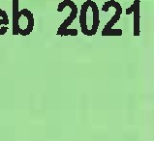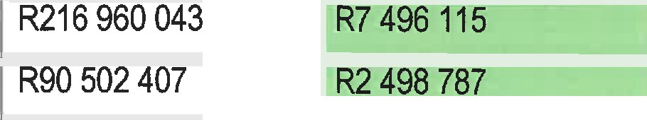Table 1. Table Mountain National Park Revenue streams

Question | 2019•20  Apr 2019 - Mar 2020  Income Description | 2020-21
(a)(ii)(aa) | Cape Point
 | Boulders

(a)(ii)(bb) | Table Mountain Aerial Cableway  Concession | R39 795 627 | R 5 217 361
(a)(ii)(cc) | My Green - and My Activity Card | R3 374 628 | R 2 643 888
(a)(ii)(dd) | Picnic Sites | R2 757 167 | R 1 251 262
(a)(ii)(ee) | Tourism Income | R7 588 972 | R 2 868 400
 | Other | R10 678 522 | R 1 555 301
Tourism Income includes Accommodation, Recreational Permits, Trail
Fees, etc.
Other includes the other Filming, Rent
Received, etc.
Total Revenue |  | R371657 366 | R23 531 114

b) The amount re-invested in operations for the 2019/20 financial year was R99 481 040. In the 2020/21 financial year, R74 498 832 has been reinvested into operations.

Regards

MS B D CREECY, MP
MINISTER OF FORESTRY, FISHERIES AND THE ENVIRONMENT
DATE: .18/03/2021

