NATIONAL ASSEMBLY

FOR WRITTEN REPLY

QUESTION NO. 07

DATE OF PUBLICATION IN INTERNAL QUESTION PAPER: 09 FEBRUARY 2023
(INTERNAL QUESTION PAPER NO. 01)

Mr P A van Staden (FF Plus) to ask the Minister of Health:
(1) Whether all government (a) hospitals and (b) clinics in each province are exempt from load shedding under the current Eskom crisis of electricity blackouts; if not, why not; if so, (i) which government (aa) hospitals and (bb) clinics in each province are still not exempt from load shedding and (ii) what measures are being put in place to ensure that all state- and provincial hospitals and clinics are exempt from load shedding;
(2) whether he will make a statement on the matter? NW7E

REPLY:
- (a-b) Not all government facilities have been exempted from the load-shedding. However, the National Department of Health has provided Eskom with a total of 213 hospitals to be considered for possible exclusion from loadshedding. About 67% of these hospitals are supplied by municipalities while Eskom supplies about 33% of the identified hospitals. Out of the 213 hospitals, 76 hospitals have been exempted of which 26 are directly supplied by Eskom and 50 by Municipalities. The number of hospitals exempted to date have doubled since the meeting held on 22 September 2022 between Eskom and National Department of Health.

- (aa) See below the number of hospitals that are exempted to date across the country:
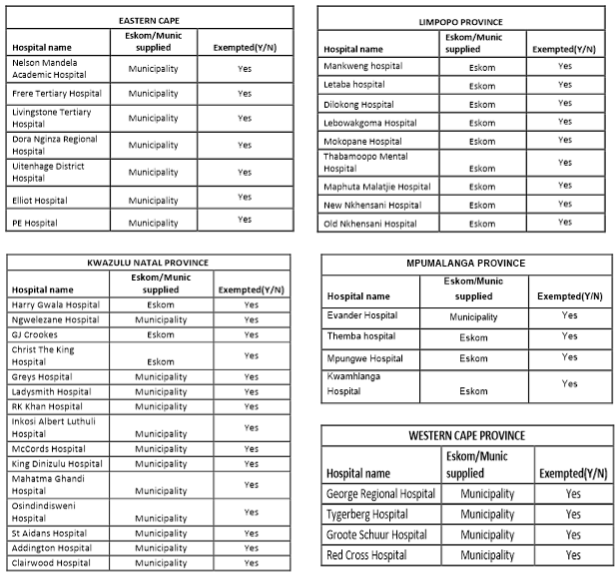

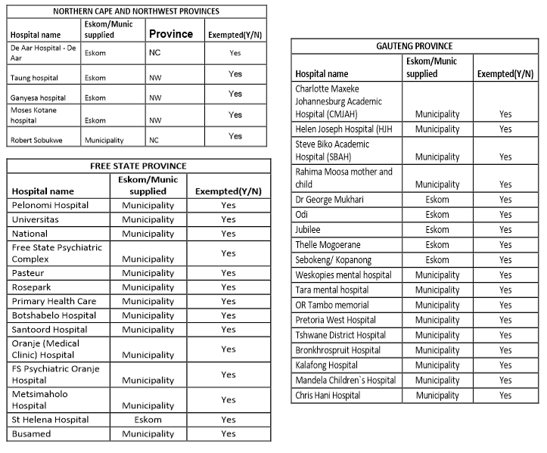

- (bb) Clinics and Community Health Centres are going to be covered within the solar energy roll-out programme.

- The National Department of Health in partnership with CSIR (Council for Scientific & Industrial Research) is currently conducting a due diligent exercise for the installation of solar panels at all our health facilities

END.

