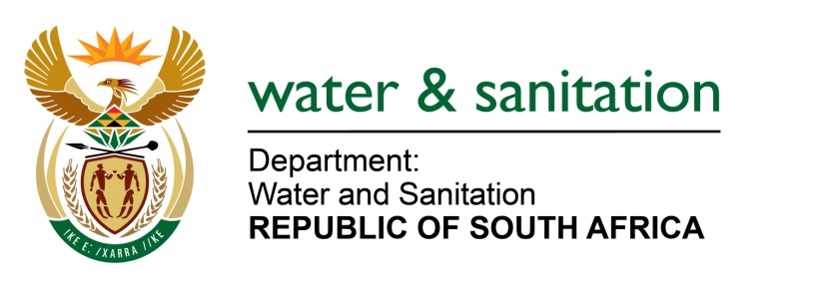

NATIONAL ASSEMBLY

FOR WRITTEN REPLY

QUESTION NO 7

DATE OF PUBLICATION IN INTERNAL QUESTION PAPER: 8 FEBRUARY 2018
(INTERNAL QUESTION PAPER NO. 1)

7. Ms D Carter (Cope) to ask the Minister of Water and Sanitation:
(1) What is the total amount of funding that has been allocated to the Maluti-a-Phofung Local Municipality for the development of boreholes for the provision of water (a) in the (i) 2015-16 and (ii) 2016-17 financial years and (b) since 1 April 2017;
(2) (a) what number of boreholes were intended to be developed, (b) what is the total number of boreholes that was developed and (c) have all the funding been accounted for since 1 April 2015? NW8E

---00O00---
REPLY:

(1)(a)(i) There is no amount of funding that has been allocated to Maluti-a-Phofung Local Municipality in the 2015-16 financial year.

(1)(a)(ii) There is a total amount of R15,000,000 that has been allocated to Maluti-a-Phofung Local Municipality in the 2016-17 financial year.

(b) The total amount of R15,000,000 has been allocated to Maluti-a-Phofung Local Municipality since 1 April 2017.

(2)(a) A total of 60 Boreholes are intended for development over a multi-year phased approach through Sedibeng Water as the Implementing Agent.

(2)(b) A total of 55 Boreholes have been drilled.
- Two contractors have been appointed for equipping and construction of boreholes in Area 3 and Area 4.
- 30 hand pumps were developed in the Qwaqwa area through support from the National Lottery.
- In addition, the Department has provided 80,000 litres of storage for the supply of water from a municipal borehole in Bolata.

(2)(c) All work on the ground and payments made to date has been verified.

---00O00---

