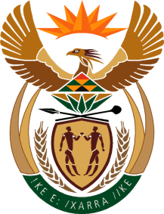

MINISTRY OF TOURISM
REPUBLIC OF SOUTH AFRICA

Private Bag X424, Pretoria, 0001, South Africa. Tel. (+27 12) 444 6780, Fax (+27 12) 444 7027
Private Bag X9154, Cape Town, 8000, South Africa. Tel. (+27 21) 469 5800, Fax: (+27 21) 465 3216

NATIONAL ASSEMBLY:

QUESTION FOR WRITTEN REPLY:
Question Number: 697
Date of Publication: 24 April 2020
NA IQP Number: 12
Date of reply: 14 MAY 2020

Mr K P Sithole (IFP) to ask the Minister of Tourism:
(a) What (i) number and (ii) percentage of international tourists have (aa) postponed their visits to the Republic and (bb) cancelled their visits amidst the COVID-19 pandemic affecting the Republic and (b) how does she intend to ensure that both (i) local and (ii) international tourism improve once the current situation has been resolved? NW899E

Reply:
- (i) and (ii)(aa) Number and percentage of international tourist that have postponed their visits to the Republic
Information not available

- and (ii)(bb) Number and percentage of international tourist that have cancelled their visits to the Republic

Information not available

- (i) How will the minister ensure that local tourism improve once the current situation has been resolved
(ii)How will the minister ensure that international tourism improve once the current situation has been resolved?

The Department and SA Tourism are currently developing a recovery plan which will be centred around three strategic objectives of; re-igniting demand, rejuvenating supply and strengthening enabling capability. The gathering of information and inputs is currently underway through industry webinars and this will assist in further development and finalising of the plan. Initial indications are that the Recovery will be led by Domestic, then Regional and ultimately International, what is currently unknown are the durations of both the phases and pace of the recovery.

