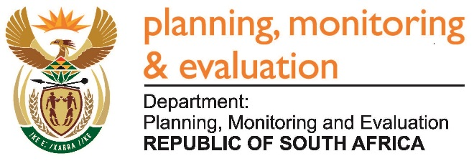 |  | 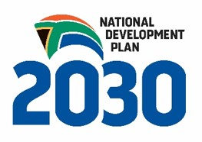
Private Bag X944, PRETORIA, 0001. Union Buildings East Wing, Government Avenue, PRETORIA
Tel: 012 312 0307. www.dpme.gov.za
696. Mr T Z Hadebe (DA) to ask the Minister in The Presidency:
(1) Did (a) his Office or (b) any entity reporting to it participate in the Dialogue with the President: Unpacking of the SONA 2017 on Radical Economic Transformation Implementation event hosted at the Oyster Box Hotel in Umhlanga, Durban, on 25 February 2017; if so, what amount was spent in each case;
(2) did (a) his Office or (b) any entity reporting to it participate in the auction of the (i) souvenirs or (ii) personal belongings of the President of the Republic, Mr Jacob G Zuma; if so, (aa) which items were purchased and (bb) at what cost, in each case? NW755E
REPLY
No.

Approved / Not Approved

Mr J T Radebe, MP
Minister in The Presidency
Date

