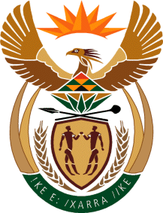

MINISTRY: COMMUNICATIONS
REPUBLIC OF SOUTH AFRICA
Private Bag X 745, Pretoria, 0001, Tel: +27 12 473 0164 Fax: +27 12 473 0585
Tshedimosetso House,1035 Francis Baard Street, Tshedimosetso House, Pretoria, 1000

NATIONAL ASSEMBLY
QUESTION FOR WRITTEN REPLY
QUESTION NUMBER: 696
DATE OF PUBLICATION: MARCH 2016

Ms P T van Damme (DA) to ask the Minister of Communications:

(1) Whether she was informed of the SA Broadcasting Corporation’s (SABC) decision to ban call-ins on its radio stations; if not, why not; if so, what is her department’s position on the SABC’s decision to ban call-ins on its radio stations; (2) whether the SABC Board was informed of the SABC’s decision to ban call-ins on its radio stations; if not, why not; if so, (a) when and (b) what are the further relevant details? NW811E

REPLY: MINISTER OF COMMUNICATIONS

There was no decision to ban call-ins on radio SABC’s stations. The SABC management did not prohibit talk shows hosts from having open lines discussions during programmes. Talk show hosts of religious or sport programmes are subject matter experts and will have open line discussions on relevant religious or sporting matters. At the same time, political discussions can only be dealt with during News and Current affairs programmes where presenters/hosts are skilled to deal with these matters. Therefore, the SABC strives to ensure that political discussions are dealt with on the correct platforms.

MR NN MUNZHELELE
DIRECTOR GENERAL [ACTING]
DEPARTMENT OF COMMUNICATIONS
DATE:

MS AF MUTHAMBI (MP)
MINISTER OF COMMUNICATIONS
DATE

