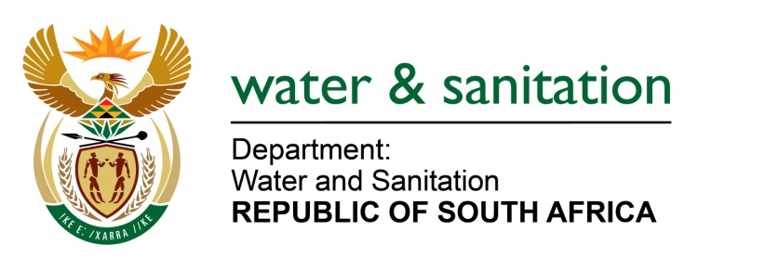

NATIONAL ASSEMBLY

FOR WRITTEN REPLY

QUESTION NO 695

DATE OF PUBLICATION IN INTERNAL QUESTION PAPER: 03 MARCH 2023
(INTERNAL QUESTION PAPER NO. 6)

695. Ms S A Buthelezi (IFP) to ask the Minister of Water and Sanitation:
With the recent surge in floods in provinces such as KwaZulu-Natal and the Eastern Cape, what is his department doing to ensure more resilient and protected water and sanitation infrastructure to ensure that his department is not continuously rebuilding infrastructure that are damaged when disasters such as floods occur?
NW771E
---00O00---

MINISTER OF WATER AND SANITATION

Civil engineering designs for water storage infrastructure i.e. Dam Walls, are designed for a safety evaluation flood (SCF) of 1:10 000 year flood conditions to ensure that the structural integrity of the wall would not be compromised by forces anticipated to be associated with such conditions. In addition, the Department is also prohibiting the erection of permanent structures within the 1:100 flood line adjacent to the full supply level of a dam and rivers as a means to safeguard life and livelihood. Wherever water conveyance structures (i.e. large pipe-lines and canals) are elevated and exposed at stream or river crossings, the bridge structure is designed to withstand 1:100 year flood conditions.

The Department takes note of the impact the intense flooding had on trenched pipe-lines during the 2022 floods and will work with research institutions to consider an amendment to engineering design factors, as influenced by climate change.

---00O00---

