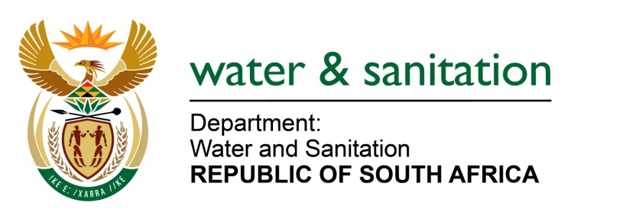

MINISTER OF WATER AND SANITATION

FOR WRITTEN REPLY

QUESTION NO 695

DATE OF PUBLICATION IN INTERNAL QUESTION PAPER: 4 MARCH 2022
(INTERNAL QUESTION PAPER NO. 6)

695. Mr L J Basson (DA) to ask the Minister of Water and Sanitation:

What (a) is the new timeline for completing the Clanwilliam Dam project and (b) will the new cost be?
---00O00---

MINISTER OF WATER AND SANITATION

- The raising of Clanwilliam Dam project will be completed by April 2026 as per the current approved programme.
- The revised cost is R 3 920 000 000 as per current project cost estimate.

NW833E
---00O00---

