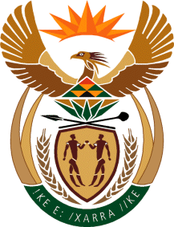

MINISTRY: COMMUNICATIONS
REPUBLIC OF SOUTH AFRICA
Private Bag X 745, Pretoria, 0001, Tel: +27 12 473 0164 Fax: +27 12 473 0585
Tshedimosetso House,1035 Francis Baard Street, Tshedimosetso House, Pretoria, 1000

NATIONAL ASSEMBLY
QUESTION FOR WRITTEN REPLY
QUESTION NUMBER: 695
DATE OF PUBLICATION: MARCH 2016

Ms P T van Damme (DA) to ask the Minister of Communications:

(a) How many times has the SA Broadcasting Corporation Board of Directors met since 1 January 2015, (b) what was the agenda for each meeting, (c) who was present at each meeting and (d) what decisions were taken at each meeting? NW810E

REPLY: MINISTER OF COMMUNICATIONS

The SABC Board reports directly to the Shareholder. Information about the frequency of meetings and attendance registers thereof are contained in the annual report of the SABC, the same will apply to meetings of SA Broadcasting Corporation Board of Directors held from 1 January 2015 to date. The agendas and decisions that were taken at these meetings are confidential and not intended for public discussion.

MR NN MUNZHELELE
DIRECTOR GENERAL [ACTING]
DEPARTMENT OF COMMUNICATIONS
DATE:

MS AF MUTHAMBI (MP)
MINISTER OF COMMUNICATIONS
DATE:

